**Project Report**

on

**UPERMIT**

to be developed to fulfil the requirements for

**Major Project (22CA015)**

Submitted to

Department of Computer Applications

Chitkara University, Punjab

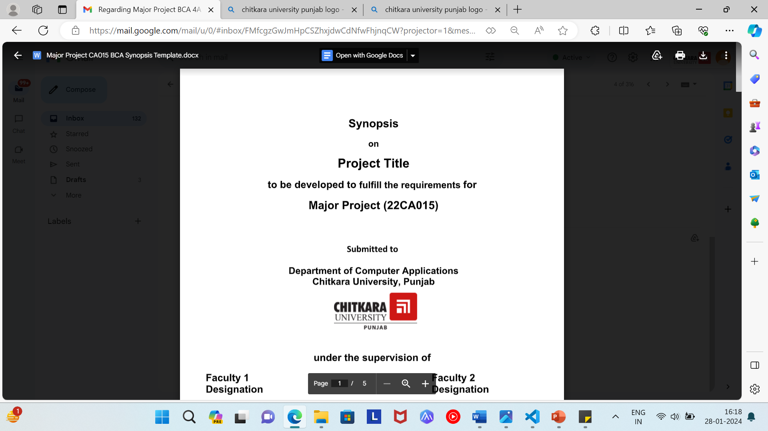

under the supervision of

Dr. Amanpreet Singh Dr. Varun Malik

Assistant Professor Associate Professor

Submitted by

Simran Kaur

2210997236

Mehardeep Kaur

2210997287

Swati Thakur

2210997249

75.

Bachelor of Computer Applications

(Batch 2022-25)

**CHITKARA UNIVERSITY, PUNJAB**

**CERTIFICATE BY THE SUPERVISOR(S)**

**This is to certify that the project entitled "UPERMIT" was successfully completed on [24-04-2024] by Mehardeep Kaur (2210997287), Simran Kaur (2210997236), and Swati Thakur (2210997249) under my direct supervision.**

UPERMIT, standing for "University Leave Management System," represents a significant advancement in the realm of academic administration. Developed with a keen understanding of the challenges faced in managing various types of student leaves—be it medical, duty, or sports—UPERMIT introduces an innovative automated system designed to streamline the entire leave application and approval processes. Through its user-friendly interface, students can effortlessly submit leave requests, specifying the type and duration of leave, along with any necessary documentation, thereby simplifying what was once a cumbersome and time-consuming task.

This certificate acknowledges the successful implementation of UPERMIT, a pioneering project aimed at revolutionizing leave management within the university environment. UPERMIT introduces an innovative automated system designed to streamline leave application and approval processes, enhance data storage and analysis, and foster seamless communication between the university and parents. By leveraging cutting-edge technology and best practices in leave management, UPERMIT embodies a commitment to efficiency, transparency, and accountability, ultimately enriching the academic experience and strengthening the bond between the institution, students, faculty, and parents.

Dr. Amanpreet Singh Dr. Varun Malik

Assistant Professor Associate Professor

TABLE OF CONTENTS

1. Abstract of the project (abstract of actual work done).

2. Profile of problems assigned.

3. Study of existing system, if any.

4. System requirements

a. Product Definition

a) Problem Statement

b) Function to be provided

c) Processing Environment

d) Solution Strategy

e) Acceptance Criteria

b. Feasibility Analysis

c. Project Plan

a) Team Structure

b) Development Schedule

c) Programming Languages And Development Tools

5. System Requirement Specifications

a. Developing / Operating / Maintenance Environments

b. External Interface And Data Flows

a. User display and report format, user command summary

b. High level DFD

c. Functional and performance specifications

6. Design

a. Detailed DFD’s and structure diagrams

b. Data structures, database and file specifications

7. Test Plan

a. Functional, Performance, Stress tests etc.

8 Implementation / Conversion Plan

9. Project Legacy

a. Current status of project

b. Remaining areas of concern

c. Technical and managerial lessons learnt

d. Future recommendations

10. Bibliography

1. Abstract

We entitle our project by the name of “UPERMIT”. The purpose of this project is to develop an automated system that will facilitate the management of different types of leaves for students regardless of being hostelers or non-hostelers in a university setting. These leaves include sick/medical leaves, duty leaves, and sports leaves, which are often required for various reasons such as illness, professional development, or extracurricular activities. The current process of applying for and approving these leaves is manual, time-consuming, and prone to errors. This project aims to simplify and speed up this process by allowing students to submit their leave requests online and enabling the management to review and respond to them quickly and conveniently.

Furthermore, the project will store the data of all the leave requests and records in a database, which can be easily accessed and analysed by the mentors. This will help them monitor the attendance patterns, leave balances, and academic performance of the students, as well as the availability and workload of the staff members.

Additionally, the project will send a mail of the leave requests to the parents via email , so that they can keep track of their children’s activities and achievements both inside and outside the school. By doing so, the project will enhance the efficiency, transparency, and record-keeping of the university administration, as well as the communication and collaboration between the university and the parents.

Working of UPERMIT Project

The UPERMIT project consists of three distinct panels: the Student Panel, the Parent Panel, and the Admin Panel. Each panel serves a specific purpose to facilitate the smooth operation of the project.

Student Panel

The Student Panel serves as the primary interface for students. In order to register, the student is required to enter a one-time password (OTP) sent to their parent portal. Without this OTP, the student will not be able to register. This verification process ensures the security and authenticity of the student's registration.

In addition to registration, the Student Panel offers various leave options for the students. Students can apply for three types of leaves: medical, duty, and sports. However, certain basic illnesses such as cough and cold are not eligible for medical leave. This differentiation aims to maintain discipline and avoid unnecessary leave requests.

1.

Other options available in the Student Panel include leave extension, check status, and follow-up. These features enable students to request an extension of their existing leave, inquire about the status of their request, and communicate with the relevant authorities regarding any updates or concerns.

Parent Panel

The Parent Panel serves as the primary interface for parents. Parents will receive an email whenever a student wants to register. This ensures the correctness of the data as well as a check that the registration is done with relevant details. The parent will receive an email even when a student wants to apply for leave.

The Admin Panel has the authority to approve or reject leave requests. When a student applies for a leave, the Admin Panel reviews the request and decides whether to grant it. If the request is approved, the Admin Panel will share the Excel sheet with the parent, providing them with comprehensive information about their child's attendance and progress.

Conclusion

In today's fast-paced educational landscape, the efficient management of student leaves stands as a crucial aspect of ensuring academic continuity and fostering a supportive learning environment. Recognizing the challenges posed by manual processes riddled with inefficiencies and errors, the introduction of "UPERMIT" marks a significant milestone in revolutionizing university leave management. Through its innovative approach and user-centric design, UPERMIT offers a comprehensive solution tailored to the needs of students, parents, and administrators alike.

At the heart of UPERMIT lies its three distinct panels: the Student Panel, the Parent Panel, and the Admin Panel. Each panel serves as a dedicated interface, seamlessly integrating functionalities to streamline leave application, monitoring, and decision-making processes.

In essence, UPERMIT transcends traditional paradigms of leave management, ushering in a new era of efficiency, transparency, and collaboration within university settings. By harnessing the power of technology to streamline processes and empower stakeholders, UPERMIT not only optimizes administrative workflows but also enriches the educational experience for students and cultivates meaningful partnerships with parents. As a catalyst for positive change, UPERMIT embodies the vision of a harmonious ecosystem where the collective efforts of students, parents, and administrators converge to shape a brighter future for academia.

2.

2. Profile Of Problems Assigned

**Technical Problems:**

1. Secure Login System:

Developing a secure login system for students, parents, and administrators is paramount to safeguarding sensitive data and ensuring the integrity of the UPERMIT platform. Implementing robust authentication mechanisms, such as multi-factor authentication and encryption protocols, will mitigate the risk of unauthorized access and data breaches. Additionally, regular security audits and updates are essential to identify and address potential vulnerabilities proactively.

1. Efficient Database Design:

Designing a database capable of efficiently storing and managing leave request data, attendance records, and student performance information is crucial for the seamless operation of UPERMIT. Utilizing relational database management systems (RDBMS) and employing normalization techniques will optimize data storage and retrieval processes, enhancing performance and scalability. Moreover, implementing data encryption and access controls will ensure the confidentiality and integrity of sensitive information stored within the database.

1. User-Friendly Interface:

Creating a user-friendly interface for each panel (Student, Parent, Admin) is essential to facilitate ease of navigation and comprehension. Employing intuitive design principles, such as clear navigation menus, descriptive labels, and interactive elements, will enhance usability and user satisfaction. Conducting usability testing and gathering feedback from stakeholders will enable iterative improvements to the interface, ensuring a seamless user experience for all users.

1. Automated Workflows for Leave Approvals:

Implementing automated workflows for leave approvals based on pre-defined criteria is critical to expedite the processing of leave requests and ensure consistency in decision-making. Configuring rule-based systems that automatically approve certain types of leaves, such as short sick leaves with a doctor's note upload, will reduce administrative burden and turnaround time. Furthermore, integrating decision support tools and machine learning algorithms can enhance the accuracy and efficiency of the automated approval process.

1. Accessibility Compliance:

Ensuring that the UPERMIT platform is accessible for users with disabilities is essential to promote inclusivity and compliance with accessibility standards such as the Web Content Accessibility Guidelines (WCAG). Incorporating features such as keyboard navigation, screen reader compatibility, and alternative text for multimedia content will ensure accessibility for users with visual, auditory, motor, and cognitive impairments. Conducting accessibility audits and user testing with individuals with disabilities will help identify and address accessibility barriers effectively.

Conclusion:

By addressing these key challenges, UPERMIT can realize its full potential as a transformative solution for leave management within the university environment. By prioritizing security, efficiency, usability, automation, integration, and accessibility, UPERMIT can deliver tangible benefits for students, parents, administrators, and other stakeholders, ultimately enhancing the overall academic experience and fostering a culture of excellence within the institution.

3.

**Functional Problems:**

1. Clear Guidelines for Leave Types:

Defining clear guidelines for different leave types, including medical, duty, and sports leaves, is essential to standardize the leave application process and ensure consistency in decision-making. This involves establishing eligibility criteria for each leave type, specifying supporting document requirements (e.g., medical certificates, duty rosters, sports event schedules), and outlining the procedures for submitting and processing leave requests. By providing comprehensive guidance, UPERMIT can empower users to navigate the leave management process effectively and mitigate ambiguity or misunderstandings.

1. Handling Leave Extensions and Cancellations:

Developing a system for handling leave extensions and cancellations is crucial to accommodate changing circumstances and ensure flexibility in leave management. UPERMIT should allow users to submit requests for leave extensions or cancellations through the platform, specifying the reasons for the change and providing any necessary documentation. Administrators should be able to review and approve these requests efficiently, updating the leave status accordingly and communicating any changes to relevant stakeholders. By facilitating seamless adjustments to leave schedules, UPERMIT can accommodate unforeseen events and promote a dynamic approach to leave management.

1. Communication Module for Notifications and Updates:

Designing a robust communication module to send notifications and updates to students, parents, and administrators regarding leave requests and approvals is essential to keep all stakeholders informed and engaged throughout the leave management process. UPERMIT should support automated notifications for various events, such as leave application submission, approval status changes, leave extension requests, and cancellations. These notifications should be customizable based on user preferences and delivered through multiple channels, including email, SMS, and in-app notifications. By maintaining transparent and timely communication, UPERMIT can enhance user satisfaction and foster trust in the leave management process.

1. Reporting and Analysis for Informed Decision-Making:

Creating reports that analyze leave patterns, staff workload, and student attendance is critical for informed decision-making and resource allocation. UPERMIT should offer a comprehensive reporting module that allows administrators to generate customized reports based on various parameters, such as leave type, duration, frequency, and requester demographics. These reports should provide insights into trends and patterns in leave utilization, staff availability, and student attendance, enabling administrators to identify areas for improvement, optimize staffing levels, and allocate resources effectively. By leveraging data-driven insights, UPERMIT can support evidence-based decision-making and enhance operational efficiency within the university environment.

Conclusion:

By addressing these functional challenges and implementing the proposed solutions, UPERMIT can enhance its functionality and effectiveness as a comprehensive leave management system. By defining clear guidelines for leave types, handling leave extensions and cancellations, facilitating communication, and providing insightful reports, UPERMIT can streamline the leave management process, improve user experience, and support informed decision-making within the university community.

4.

3. Study Of Existing System:

Introduction:

The Student Leave Management System serves as a pivotal tool in educational institutions, facilitating the recording, processing, and tracking of leave requests for students. While the system plays a crucial role in managing student absences, it is essential to evaluate both its features and limitations to identify areas for improvement. This document provides an overview of the existing features of the Student Leave Management System, followed by an analysis of its limitations and challenges.

**Features of the Existing System:**

1. Record Keeping:

The existing system enables administrative users to maintain leave records manually. Each leave request is meticulously recorded, tracked, and updated, providing a comprehensive historical record of student absences within the institution. While manual record-keeping ensures data accuracy, it also poses challenges in terms of scalability and efficiency.

1. Application Processing:

Students can submit leave requests through the system, specifying the type and duration of leave required. Administrative users play a pivotal role in reviewing and processing these requests, updating the status of each application accordingly. This feature streamlines the leave application process, ensuring prompt and accurate responses to student requests.

1. Data Access:

While the system provides access to leave records, retrieving historical data or generating reports can be cumbersome. Users may encounter challenges in navigating through complex record-keeping systems to access information on leave applications. Improved data accessibility and reporting functionalities are essential for enhancing the system's usability and effectiveness.

1. User Interface:

The user interface of the existing system may vary in usability, depending on the specific implementation. While some versions offer a straightforward interface with intuitive design features, others may lack usability enhancements, leading to potential user experience issues. A user-friendly interface is critical for ensuring ease of navigation and maximizing user engagement with the system.

5.

1. Communication:

Basic communication features are integrated into the system, allowing administrators to communicate with students regarding leave requests and approvals. However, the effectiveness of communication may be limited by the system's capabilities. Enhancing communication functionalities can improve stakeholder engagement and facilitate seamless collaboration within the institution.

Conclusion:

In conclusion, the existing Student Leave Management System offers several valuable features for managing student absences. From comprehensive record-keeping and streamlined application processing to basic communication capabilities, these features play a crucial role in facilitating leave management within educational institutions. However, there is room for improvement in terms of data accessibility, user interface design, and communication functionalities. By addressing these areas of improvement, the system can enhance usability, efficiency, and overall user experience, ultimately improving the effectiveness of leave management processes.

**Limitations of the Existing System:**

1. Manual Record-Keeping:

A primary limitation of the existing leave application software is its reliance on manual record-keeping. Administrative users are burdened with the task of inputting leave data manually, leading to increased administrative workload and a higher risk of errors. This manual approach not only consumes valuable time and resources but also introduces the potential for data inaccuracies and inconsistencies.

1. Data Inconsistencies:

Manual data entry in the existing system increases the likelihood of inconsistencies and inaccuracies in leave records. Errors in data entry can lead to misunderstandings, delays, and potential rejections of leave applications, ultimately impacting user satisfaction. The lack of automated data validation processes further exacerbates this issue, making it challenging to maintain data integrity and reliability.

6.

1. Limited Accessibility:

The existing leave application software may face challenges in terms of accessibility and data retrieval. Users may encounter difficulties in accessing and retrieving historical leave data or generating reports, leading to inefficiencies in decision-making and resource allocation. This limited accessibility impedes the timely retrieval of critical information, hindering the effectiveness of leave management processes.

1. Scalability Issues:

As the volume of leave requests increases, the existing system may struggle to scale effectively. Manual record-keeping processes can become overwhelmed, resulting in delays and bottlenecks in leave processing. This scalability issue poses significant challenges in managing peak periods of leave requests, potentially impacting service delivery and user satisfaction.

1. Lack of Integration:

In some cases, the existing leave application software lacks integration with other institutional systems, such as student information systems or communication platforms. This lack of integration hinders data exchange and communication, leading to disjointed workflows and inefficiencies. Seamless integration with other systems is essential for facilitating streamlined processes and enhancing overall organizational efficiency.

Conclusion:

In conclusion, while the existing leave application software provides essential features for managing student absences, it is hampered by several limitations. From manual record-keeping and data inconsistencies to limited accessibility, scalability issues, and lack of integration, these challenges underscore the need for a more streamlined and automated leave management solution. By addressing these limitations and implementing a modernized leave management system, educational institutions can enhance efficiency, accuracy, and user experience, ultimately improving the overall effectiveness of leave management processes.

7.

4. System Requirements:

**a. Product Definition**

**a) Problem Statement**

Introduction:

The leave application process at our university currently operates under a manual system, which poses several significant challenges. This outdated method is characterized by its time-consuming nature, susceptibility to errors, and lack of transparency. As a result, it imposes considerable burdens on students, staff, and administrators alike. This document aims to elaborate on these challenges, emphasizing the urgent need for a more efficient and reliable leave management system.

Time-Consuming Nature:

One of the foremost issues plaguing the existing leave management system is its time-consuming nature. Under this manual process, students and staff are required to physically fill out leave application forms, which then undergo a cumbersome approval process involving multiple stakeholders. The time taken from the initial application submission to final approval often spans several days, if not weeks, leading to delays in leave processing. Moreover, the need for physical documentation adds to the inefficiency, as it necessitates in-person visits to administrative offices, further prolonging the process.

Susceptibility to Errors:

Another critical drawback of the current system is its inherent susceptibility to errors. Manual data entry leaves ample room for mistakes, ranging from clerical errors in filling out forms to inaccuracies in recording leave balances. These errors not only undermine the integrity of leave records but also contribute to confusion and disputes regarding leave entitlements. Furthermore, the decentralized nature of the manual process increases the likelihood of discrepancies between different records maintained by various departments or individuals, exacerbating the problem.

Lack of Transparency:

Transparency is crucial in any organizational process, yet the current leave management system lacks this essential element. Without a centralized and accessible platform for leave applications and approvals, stakeholders are often left in the dark regarding the status of their leave requests. Students and staff are unaware of the progress of their applications, leading to frustration and uncertainty. Additionally, the absence of transparent guidelines and policies further compounds the issue, as individuals may be unclear about eligibility criteria or procedural requirements, resulting in inconsistent application of leave policies.

8.

Impact on Stakeholders:

The inefficiencies inherent in the existing leave management system have far-reaching implications for all stakeholders involved. For students, delayed leave approvals can disrupt academic schedules and personal commitments, causing undue stress and inconvenience. Similarly, staff members face challenges in balancing work and personal responsibilities when confronted with lengthy approval processes and potential errors in leave records. Administrators, burdened with manual processing tasks and troubleshooting errors, find themselves diverted from more strategic responsibilities, hampering overall productivity and efficiency.

Conclusion:

In conclusion, the current manual leave application process at our university represents a significant impediment to efficiency, accuracy, and transparency. The challenges posed by its time-consuming nature, susceptibility to errors, and lack of transparency undermine the well-being and productivity of students, staff, and administrators alike. Addressing these issues requires the implementation of a modernized leave management system that leverages technology to streamline processes, ensure data accuracy, and enhance transparency. By doing so, the university can alleviate the burdens imposed by the existing system and foster a more conducive environment for academic and administrative operations.

**b) Function to be Provided:**

Introduction:

UPERMIT (University Personnel Leave Management Information Technology) is an innovative automated system designed to revolutionize the management of various leave types for students within the university. By leveraging cutting-edge technology, UPERMIT offers a range of functionalities aimed at streamlining the leave application process, enhancing record-keeping capabilities, and facilitating effective communication between stakeholders. This document elaborates on the key functions provided by UPERMIT, highlighting its benefits for students, administrative staff, and faculty members.

1. Online Leave Application and Approval:

One of the primary functions of UPERMIT is to facilitate seamless online leave application and approval processes. Through a user-friendly interface accessible via web or mobile devices, students can submit leave requests conveniently from anywhere, eliminating the need for cumbersome paper-based forms. The system allows students to specify the type of leave (such as medical, duty, or sports), duration, and relevant details. Upon submission, the application is automatically routed to the appropriate authority for review and approval. Administrative staff and faculty members can access the system to review pending leave requests, make decisions, and provide feedback in a timely manner. This streamlined process reduces the administrative burden associated with manual leave processing and ensures faster turnaround times for leave approvals.

9.

2. Leave Tracking and Record Keeping:

UPERMIT offers robust leave tracking and record-keeping capabilities, enabling accurate monitoring of students' leave balances, usage history, and accrued entitlements. Upon approval, leave requests are automatically recorded in the system, updating students' leave balances in real-time. This feature provides students with visibility into their available leave quotas and helps prevent overutilization or discrepancies in leave entitlements. Additionally, administrators and faculty members can generate comprehensive reports and analytics to gain insights into leave trends, patterns, and compliance with institutional policies. By centralizing leave data in a secure digital repository, UPERMIT minimizes the risk of errors, improves data integrity, and facilitates audits or compliance checks.

3. Communication Tools for Leave Updates and Status Inquiries:

UPERMIT enhances communication between stakeholders by providing dedicated tools for leave updates and status inquiries. Upon submission of a leave request, students receive instant confirmation and notifications regarding the status of their application, including any changes or updates. Similarly, administrative staff and faculty members receive alerts for pending leave requests requiring their attention, ensuring prompt action and timely responses. The system also enables two-way communication, allowing students to seek clarifications, provide additional information, or request modifications to their leave applications as needed. This transparent and interactive communication framework fosters collaboration, reduces ambiguity, and promotes accountability in the leave management process.

Conclusion:

UPERMIT represents a comprehensive solution for automating leave management processes and enhancing efficiency, transparency, and communication within the university. By offering online leave application and approval functionalities, robust leave tracking and record-keeping capabilities, and dedicated communication tools, UPERMIT addresses the key pain points associated with manual leave management systems. With its user-friendly interface, seamless integration, and data-driven insights, UPERMIT empowers students, administrative staff, and faculty members to effectively manage leave-related activities and ensure smooth operations across the university ecosystem.

**c) Processing Environment: Hardware (H/W), Software (S/W)**

Hardware:

In order to support the functionality of UPERMIT (University Personnel Leave Management Information Technology), a robust hardware infrastructure is essential. The hardware components required for the processing environment include:

10.

1. Standard Computers with Internet Access:

All users, including students, staff, and administrators, will utilize standard computers with internet access to interact with the UPERMIT system. These computers serve as the primary interface through which users submit leave requests, review leave balances, and access system features. Whether desktops or laptops, these devices enable seamless communication with the UPERMIT server and facilitate efficient leave management processes.

1. Server:

A dedicated server is necessary to host and manage the UPERMIT application and database. This server acts as the central hub for processing leave requests, storing user data, and facilitating communication between the client-side interfaces and the backend system. The server should be equipped with sufficient processing power, memory, and storage capacity to handle concurrent user interactions, database queries, and system operations efficiently.

Software:

The software components of the UPERMIT processing environment encompass various technologies and frameworks essential for system development, deployment, and operation. These software components include:

1. Operating System (OS):

The choice of operating system for the server depends on factors such as compatibility, security, and performance requirements. Options include Windows Server, macOS Server, or Linux distributions such as Ubuntu or CentOS. The selected OS provides the foundational framework for hosting the UPERMIT application, managing server resources, and ensuring system stability and reliability.

1. Website Framework:

UPERMIT's user interface is developed using a combination of web technologies, including HTML, CSS, and PHP. HTML (Hypertext Markup Language) defines the structure and content of web pages, while CSS (Cascading Style Sheets) enables the styling and presentation of these pages. PHP (Hypertext Preprocessor) is utilized for server-side scripting, facilitating dynamic page generation and interaction with the backend database. Together, these frameworks form the basis of the user-friendly and responsive interface through which users interact with the UPERMIT system.

1. Database Management System (DBMS):

UPERMIT relies on a robust database management system to store, retrieve, and manage leave-related data efficiently. MySQL is a popular choice for DBMS due to its reliability, scalability, and ease of integration with web applications. The server hosts the MySQL database, which stores information such as user profiles, leave requests, approval workflows, and system configurations. By leveraging the capabilities of MySQL, UPERMIT ensures data integrity, security, and accessibility, facilitating seamless information management and retrieval.

In summary, the processing environment for UPERMIT encompasses a combination of hardware and software components designed to support the system's functionality, scalability, and reliability. Through the integration of standard computers with internet access, a dedicated server, and essential software frameworks such as the operating system, website framework, and database management system, UPERMIT offers a robust platform for streamlining leave management processes within the university ecosystem.

11.

**d) Solution Strategy**

Introduction:

The implementation of UPERMIT (University Personnel Leave Management Information Technology) revolves around a comprehensive solution strategy aimed at revolutionizing leave management within the university ecosystem. This document outlines the strategic approach to developing and deploying UPERMIT, focusing on key elements such as user panels, functionalities, and database integration.

1. Development of a Web Application:

The foundation of UPERMIT lies in the development of a user-friendly web application accessible to students, parents, and administrators. The application will feature three distinct user panels, each tailored to meet the specific needs and responsibilities of its user base.

2. Implementation of Functionalities for Each Panel:

a. Student Panel:

The Student Panel serves as the primary interface for students to manage their leave-related activities. Key functionalities include:

Registration:

Students can create accounts on the UPERMIT platform, providing necessary personal and academic information for authentication and verification purposes.

Application:

Students can submit leave requests through the application, specifying the type of leave (e.g., medical, duty, sports), duration, and any additional details. The application will include an intuitive interface for leave type selection and submission.

Extension Requests:

In cases where leave durations need to be extended, students can submit extension requests through the application, providing reasons and justifications for the extension.

Status Checks:

Students can track the status of their leave requests in real-time, receiving updates on approvals, rejections, or pending actions.

12.

Communication Features:

The Student Panel will incorporate communication features such as notifications, alerts, and messaging functionalities to facilitate seamless interaction with administrators and other stakeholders.

b. Parent Panel:

The Parent Panel offers parents a secure and convenient platform to monitor their child's attendance, performance, and leave-related information. Key functionalities include:

Login:

Parents can access the UPERMIT platform using secure login credentials, ensuring privacy and data protection.

Secure View of Attendance and Performance:

Parents can view their child's attendance records, academic performance metrics, and leave history through a dedicated dashboard. This feature provides transparency and accountability, enabling parents to stay informed about their child's academic progress.

Alternative to Excel Sheets:

UPERMIT replaces manual tracking methods such as Excel sheets with a centralized digital platform, offering parents a more efficient and reliable means of monitoring their child's educational journey.

c. Admin Panel:

The Admin Panel serves as the central control hub for administrators, enabling them to manage leave requests, oversee data management tasks, and communicate with students and staff. Key functionalities include:

Leave Request Approval/Rejection:

Administrators can review and approve/reject leave requests submitted by students, ensuring adherence to institutional policies and guidelines.

Data Management:

The Admin Panel provides tools for generating reports, analyzing leave trends, and configuring leave limit settings. These features enable administrators to make informed decisions regarding resource allocation, policy adjustments, and strategic planning.

13.

Communication with Students/Staff:

The Admin Panel includes communication tools such as email notifications, announcements, and messaging systems for facilitating interaction between administrators, students, and staff members.

3. Integration with a Secure Database:

To ensure data integrity, security, and accessibility, UPERMIT integrates with a secure database management system (DBMS) for storing user information, leave records, and performance data. The database serves as a centralized repository, facilitating efficient data retrieval, manipulation, and analysis. By leveraging a secure database infrastructure, UPERMIT ensures confidentiality, availability, and integrity of sensitive information, safeguarding the interests of all stakeholders.

Conclusion:

In conclusion, the solution strategy for UPERMIT encompasses the development of a comprehensive web application with separate user panels for students, parents, and administrators, each offering tailored functionalities to meet their unique needs. By integrating with a secure database, UPERMIT ensures reliable data management and communication capabilities, empowering stakeholders to streamline leave management processes, enhance transparency, and foster a conducive environment for academic excellence within the university ecosystem.

**e) Acceptance Criteria**

Introduction:

In order to ensure the successful implementation and adoption of UPERMIT (University Personnel Leave Management Information Technology), it is essential to define clear acceptance criteria that delineate the desired functionalities, performance standards, and user experience expectations. This document elaborates on the acceptance criteria for UPERMIT, encompassing key requirements related to accessibility, user registration, leave submission, administration capabilities, data management, security, and user interface design.

1. Accessibility:

The UPERMIT system should be accessible online from any device with an internet connection, ensuring convenience and flexibility for users.

Users should be able to access the system seamlessly across various devices, including desktop computers, laptops, tablets, and smartphones, without encountering compatibility issues or performance constraints.

14.

2. User Registration and Login Processes:

The registration process should function correctly for all user types (students, staff, admins), allowing users to create accounts and provide necessary personal information securely.

The login process should authenticate users' credentials accurately, granting access to the respective user panels based on their roles and permissions within the system.

3. Leave Submission by Students:

Students should be able to submit leave requests for different types, including sick/medical, duty, and sports leaves, through the UPERMIT platform.

The leave submission process should include provisions for students to provide justifications or supporting documents for their leave requests, ensuring transparency and accountability.

4. Administration Capabilities:

The Admin Panel should provide administrators with the ability to review and manage leave requests, including approving or rejecting requests based on institutional policies and guidelines.

Administrators should have access to features for managing leave limits, configuring leave policies, and overseeing leave-related activities within the system.

5. Leave Balances Tracking and Reporting:

The UPERMIT system should track leave balances accurately, updating balances in real-time based on approved leave requests and adjustments made by administrators.

Administrators should be able to generate comprehensive reports on leave utilization, trends, and compliance metrics, facilitating informed decision-making and strategic planning.

6. Data Security and Privacy Compliance:

UPERMIT should adhere to data security and privacy regulations, implementing robust measures to safeguard sensitive user information, leave records, and system data.

The system should incorporate encryption protocols, access controls, and authentication mechanisms to prevent unauthorized access, data breaches, or privacy violations.

15.

7. User Interface Design:**

The user interface should be user-friendly and intuitive for all user groups, featuring clear navigation, intuitive layouts, and responsive design elements.

The interface should prioritize usability, accessibility, and aesthetic appeal, enhancing user satisfaction and engagement with the UPERMIT platform.

Conclusion:

In conclusion, the acceptance criteria for UPERMIT encompass a comprehensive set of requirements spanning accessibility, user registration, leave submission, administration capabilities, data management, security, and user interface design. By adhering to these criteria, UPERMIT aims to deliver a robust, user-centric leave management solution that meets the diverse needs of stakeholders within the university community, fostering efficiency, transparency, and compliance with regulatory standards.

**b. Feasibility Analysis:**

Introduction:

UPERMIT presents a promising solution for streamlining leave management processes within the university environment. A feasibility analysis is essential to assess the viability and practicality of implementing UPERMIT, considering technical, economic, operational, and organizational factors. This document provides a brief elaboration on the feasibility analysis of UPERMIT, highlighting its potential benefits, challenges, and strategies for successful implementation.

1. Technical Feasibility:

UPERMIT's technical requirements can be met with existing technologies, including web development frameworks, database management systems, and server infrastructure.

Open-source options for software components such as PHP, MySQL, and Linux can keep development costs reasonable while ensuring scalability and compatibility.

Integration with standard hardware components such as computers with internet access and a dedicated server is feasible and straightforward.

2. Economic Feasibility:

The economic benefits of UPERMIT, including improved efficiency, reduced paperwork, and enhanced productivity, can potentially offset the initial investment in development and implementation.

Cost savings resulting from streamlined leave management processes, reduced administrative overheads, and improved resource allocation can contribute to long-term economic viability.

A cost-benefit analysis should be conducted to quantify the financial implications of implementing UPERMIT and assess its return on investment (ROI) over time.

16.

3. Operational Feasibility:

Operational challenges may arise regarding user adoption and workflow adjustments, particularly during the transition from manual to automated leave management processes.

A well-planned rollout strategy, including comprehensive training programs, user support services, and change management initiatives, can mitigate resistance to change and facilitate smooth adoption of UPERMIT.

Stakeholder engagement and collaboration are crucial for identifying operational requirements, addressing concerns, and ensuring alignment with organizational goals and priorities.

4. Organizational Feasibility:

UPERMIT's organizational feasibility depends on its alignment with the university's strategic objectives, policies, and cultural norms.

Collaboration with key stakeholders, including students, faculty members, administrative staff, and IT personnel, is essential for gaining buy-in, fostering ownership, and driving successful implementation.

Clear communication of UPERMIT's benefits, functionalities, and implementation timeline can build confidence and support among organizational stakeholders.

5. Risk Management:

Risk management strategies should be implemented to identify, assess, and mitigate potential risks and challenges associated with UPERMIT implementation.

Common risks include technical issues, data security concerns, resistance to change, and operational disruptions.

Proactive measures such as contingency planning, regular monitoring, and stakeholder engagement can help mitigate risks and ensure project success.

Conclusion:

In conclusion, UPERMIT demonstrates strong feasibility as a project aimed at enhancing leave management efficiency within the university environment. While technical requirements can be met with existing technologies, economic benefits and operational challenges must be carefully considered. A well-planned rollout strategy, stakeholder engagement, and risk management are critical for ensuring the successful implementation and adoption of UPERMIT. By addressing these factors comprehensively, UPERMIT has the potential to deliver significant value to the university community, facilitating streamlined leave management processes and fostering a culture of efficiency and transparency.

17.

**c. Project Plan**

**a) Team Structure**

Introduction:

The successful development and implementation of UPERMIT (University Personnel Leave Management Information Technology) require a well-structured team comprising diverse roles and expertise. Each team member plays a crucial role in different aspects of the project, contributing to its overall success. This document provides a brief elaboration on the roles and responsibilities of each team member within the UPERMIT project team.

1. Project Manager:

The Project Manager oversees all aspects of the UPERMIT project, including planning, execution, monitoring, and control.

Responsibilities include managing the project budget, timeline, and resources, as well as coordinating communication and collaboration among team members and stakeholders.

The Project Manager ensures that the project objectives are met within the specified constraints and that deliverables meet quality standards and user requirements.

2. System Analyst:

The System Analyst plays a critical role in analysing user needs, defining system requirements, and documenting functional specifications for UPERMIT.

Responsibilities include conducting stakeholder interviews, gathering and analysing requirements, and translating user needs into technical specifications.

The System Analyst collaborates closely with stakeholders, including students, parents, administrators, and developers, to ensure alignment between user expectations and system functionalities.

3. Web Developer (Front-end):

The Front-end Web Developer is responsible for developing the user interface (UI) for all three panels (Student, Parent, Admin) of the UPERMIT application.

Using technologies such as HTML, CSS, and JavaScript, the Front-end Developer creates visually appealing, intuitive, and responsive interfaces that enhance user experience and usability.

Responsibilities include implementing design mock-ups, ensuring cross-browser compatibility, and optimizing UI performance for various devices and screen sizes.

18.

4. Web Developer (Back-end):

The Back-end Web Developer focuses on developing the server-side logic, database integration, and application functionalities for UPERMIT.

Using programming languages and frameworks such as PHP, Python, or Node.js, the Back-end Developer implements business logic, data processing, and authentication mechanisms.

Responsibilities include designing and implementing RESTful APIs, integrating with database systems, and ensuring scalability, security, and performance of the application.

5. Database Administrator (DBA):

The Database Administrator is responsible for setting up and managing the database infrastructure for UPERMIT, ensuring data security, integrity, and availability.

Responsibilities include designing database schemas, configuring database servers, optimizing performance, and implementing backup and recovery strategies.

The DBA also collaborates with developers to define data models, enforce data validation rules, and ensure compliance with data privacy regulations.

6. QA Tester:

The QA Tester is responsible for testing the UPERMIT system functionalities for bugs, errors, and compliance with acceptance criteria.

Responsibilities include developing test cases, executing test scripts, reporting defects, and verifying fixes.

The QA Tester ensures that the UPERMIT application meets quality standards, usability requirements, and user expectations before deployment.

7. Content Writer:

The Content Writer develops user guides, training materials, and documentation for the UPERMIT system, ensuring clarity, accuracy, and accessibility of information.

Responsibilities include creating instructional content, FAQs, and help resources to assist users in navigating and using the UPERMIT application effectively.

The Content Writer collaborates with stakeholders and subject matter experts to gather information and ensure that content aligns with user needs and system functionalities.

Conclusion:

In conclusion, the team structure for UPERMIT comprises a diverse group of professionals, each contributing unique skills and expertise to the project. From project management and system analysis to web development, database administration, quality assurance, and content writing, every team member plays a crucial role in the successful development and implementation of UPERMIT. Through effective collaboration, communication, and coordination, the UPERMIT project team aims to deliver a robust, user-centric leave management solution that meets the needs of stakeholders within the university community.

19.

**b) Development Schedule**

Introduction:

The development schedule for UPERMIT is a critical component of the project planning process, outlining the sequential phases, tasks, and timelines required to bring the system from conception to deployment. This document provides a detailed elaboration on each phase of the development schedule, including planning and requirement gathering, design and development, testing and deployment.

Phase 1: Planning & Requirement Gathering (1 Week)

During the planning and requirement gathering phase, the project team focuses on defining the scope, objectives, and user requirements for UPERMIT.

Define Project Scope and Objectives:

The project manager leads efforts to define the scope of UPERMIT, outlining its key functionalities, target user groups, and expected deliverables.

Conduct User Interviews and Workshops:

System analysts engage with stakeholders, including students, parents, and administrators, to gather insights into their needs, preferences, and pain points related to leave management.

Develop Detailed System Requirements Document:

Based on user inputs and analysis, the team develops a comprehensive system requirements document, detailing user stories, functionalities, and technical specifications.

Phase 2: Design & Development (8 Weeks)

The design and development phase focuses on translating the system requirements into tangible design mock-ups and implementing the back-end logic and functionalities of UPERMIT.

Design User Interface (UI) Mock-ups:

Front-end developers create mockups of the user interface for each panel (Student, Parent, Admin), incorporating feedback from stakeholders to ensure usability and aesthetics.

20.

Develop Back-end Server Logic:

Back-end developers build the server-side logic and functionality of UPERMIT, including leave application, approval workflows, database integration, and data processing.

Implement Core Functionalities:

The development team implements core functionalities of UPERMIT, such as leave application submission, approval/rejection, leave tracking, reporting, and communication features.

Phase 3: Testing & Deployment (2 Weeks)

The testing and deployment phase involves rigorous testing of the system to identify and resolve any issues before deployment to production.

Conduct Rigorous Testing:

QA testers perform comprehensive testing of UPERMIT, including functional testing, usability testing, performance testing, and security testing, to identify bugs, errors, and deficiencies.

Fix Identified Bugs:

The development team addresses and fixes any bugs or issues identified during testing, ensuring that the system functions as designed and meets quality standards.

Deploy to Test Environment:

The system is deployed to a test environment for user acceptance testing (UAT), allowing representatives from each user group to evaluate the system and provide feedback.

Conduct UAT:

UAT is conducted with representatives from students, staff, and administrators to validate the system's usability, functionality, and alignment with user needs and expectations.

Conclusion:

The development schedule for UPERMIT spans a total of 11 weeks, divided into three phases: planning and requirement gathering, design and development, and testing and deployment. By adhering to this schedule and leveraging a structured approach to project management and development, the project team aims to deliver a robust, user-centric leave management solution that enhances efficiency, transparency, and user satisfaction within the university community.

21.

**c) Programming Languages and Development Tools**

## Front-end Development:

## HTML:

## Hypertext Markup Language (HTML) is used for structuring the content and elements of the user interface in UPERMIT. HTML provides the basic framework for displaying text, images, forms, and other interactive elements on web pages.

## CSS:

## Cascading Style Sheets (CSS) are employed to enhance the presentation and styling of HTML elements in UPERMIT. CSS allows developers to control the layout, colors, fonts, and visual aspects of the user interface, ensuring consistency and aesthetics across different pages.

## Bootstrap:

## Bootstrap is a popular front-end framework that is utilized to streamline the development of responsive and mobile-friendly web interfaces in UPERMIT. Bootstrap provides pre-designed templates, components, and utilities for building sleek, modern, and accessible user interfaces, reducing development time and effort.

## Database:

## MySQL:

## MySQL is employed as the database management system (DBMS) for storing and managing the data related to leave requests, user profiles, system configurations, and other relevant information in UPERMIT. MySQL offers robust features for data storage, retrieval, manipulation, and security, ensuring efficient and reliable access to information for users and administrators.

## Version Control System:

## Git:

## Git serves as the version control system (VCS) for managing the source code and development history of UPERMIT. Git enables collaborative development by allowing multiple developers to work on the same codebase simultaneously, tracking changes, merging modifications, and resolving conflicts effectively. Additionally, Git provides features for branching, tagging, and versioning, facilitating code organization and management throughout the development lifecycle.

22.

## Conclusion:

## The selection of programming languages and development tools for UPERMIT reflects a balanced approach to building a robust, scalable, and user-friendly leave management system. By leveraging HTML, CSS, and Bootstrap for front-end development, MySQL for database management, and8. System Requirement Specifications: Development, Operation, and Maintenance Environments

5. System Requirement Specifications:

**A. Developing Environment**

* **Hardware:**

Introduction:

The successful development of UPERMIT relies on the availability of appropriate hardware resources to support the development environment. This document outlines the hardware requirements necessary for developers to efficiently create and maintain the UPERMIT application.

Personal Computer (PC):

A personal computer serves as the primary workstation for developers involved in UPERMIT development. The following specifications are recommended to ensure smooth and efficient development work:

Modern Processor:

A PC equipped with a modern processor, such as an Intel Core i5 or equivalent, is essential for handling the computational demands of development tasks. The processor's speed and efficiency contribute to faster compilation times, smoother performance, and improved responsiveness during coding, testing, and debugging processes.

Sufficient RAM:

Adequate RAM (Random Access Memory) is crucial for multitasking and running resource-intensive development tools and applications simultaneously. A minimum of 8GB of RAM is recommended to ensure smooth performance and responsiveness, especially when working with large codebases, IDEs (Integrated Development Environments), and virtualization environments.

23.

Adequate Storage Space:

Sufficient storage space is necessary to accommodate the development tools, project files, documentation, and any additional resources required for UPERMIT development. A solid-state drive (SSD) with a capacity of 500GB or more is recommended to ensure fast read/write speeds, quick access to files, and efficient data management.

Considerations:

Developers may benefit from additional peripherals such as high-resolution monitors, ergonomic keyboards, and precision mice to enhance productivity and comfort during extended development sessions.

It is advisable to regularly maintain and optimize the hardware environment by updating drivers, installing security patches, and performing routine maintenance tasks to ensure optimal performance and reliability.

Conclusion:

The hardware requirements outlined above provide developers with the necessary resources to effectively develop, test, and maintain the UPERMIT application. By investing in modern and capable hardware, developers can optimize their workflow, minimize downtime, and deliver a high-quality and robust leave management system that meets the needs of users within the university community.

* **Software:**

Operating System:

A stable and widely used operating system forms the foundation of the development environment for UPERMIT. Developers can choose from the following options based on their preferences and familiarity:

Windows 10/11:

Microsoft's Windows operating system provides a familiar and user-friendly environment for development work. It offers compatibility with a wide range of development tools and software libraries commonly used in UPERMIT development.

macOS:

Apple's macOS offers a Unix-based environment known for its stability, security, and ease of use. Developers favor macOS for its seamless integration with development tools and intuitive user interface, making it a popular choice for UPERMIT development.

24.

Linux Distribution (e.g., Ubuntu, Fedora):

Linux distributions provide developers with a versatile and customizable environment for software development. Ubuntu and Fedora are popular choices among developers due to their robustness, community support, and compatibility with open-source development tools.

Integrated Development Environment (IDE):

An integrated development environment (IDE) serves as the primary tool for writing, editing, debugging, and testing code in UPERMIT development. Consider the following options based on the chosen programming language(s):

Visual Studio Code:

Visual Studio Code is a lightweight and versatile IDE that supports various programming languages, including HTML, CSS, JavaScript, Python, and Java. It offers a rich set of features, extensions, and integrations, making it suitable for UPERMIT development across different platforms.

Version Control System (VCS):

A version control system (VCS) is essential for tracking code changes, collaborating with team members, and managing project history in UPERMIT development. Git is a popular and recommended option due to its widespread adoption, flexibility, and feature-rich capabilities.

Git:

Git is a distributed version control system that allows developers to track changes, create branches, merge code, and collaborate with team members efficiently. It provides robust versioning, branching, and merging capabilities, making it suitable for UPERMIT development across different platforms and team sizes.

Database Management System (DBMS):

If UPERMIT utilizes a database for leave data storage, a suitable database management system (DBMS) is required. Consider the following options based on the project's requirements and preferences:

25.

MySQL:

MySQL is a popular open-source relational database management system known for its performance, reliability, and scalability. It is suitable for UPERMIT development if the project requires a relational database for storing leave data.

Microsoft SQL Server:

Microsoft SQL Server is a comprehensive relational database management system developed by Microsoft. It offers enterprise-grade features, scalability, and integration with other Microsoft technologies, making it suitable for UPERMIT development in Windows-based environments.

Conclusion:

The software requirements outlined above provide developers with the necessary tools and platforms to effectively develop, test, and maintain the UPERMIT application. By selecting stable and widely used operating systems, integrated development environments, version control systems, and optional database management systems, developers can optimize their workflow, collaborate efficiently, and deliver a high-quality leave management system that meets the needs of users within the university community.

**Operating Environment**

* **Hardware:**

A server with reliable hardware specifications is essential to ensure optimal performance and reliability for the UPERMIT system. The specific hardware requirements will depend on factors such as the number of users, anticipated usage patterns, and scalability for future growth. Consider the following guidelines when selecting server hardware:

Processing Power:

Choose a server with sufficient processing power to handle the system load efficiently. This includes a multi-core processor (e.g., Intel Xeon or AMD Ryzen) with high clock speeds and adequate cache memory to execute multiple tasks concurrently.

Memory (RAM):

Ensure the server is equipped with ample memory (RAM) to support concurrent user sessions, database operations, and application processes. The recommended amount of RAM will vary depending on the anticipated usage and the size of the dataset being processed. Aim for a minimum of 16GB to 32GB of RAM, with the option to expand as needed.

26.

Storage:

Select storage solutions that provide fast access times, high throughput, and sufficient capacity to store application files, databases, logs, and other system data. Consider using solid-state drives (SSDs) for improved performance and reliability, especially for database storage. Allocate adequate storage space based on anticipated data growth and backup requirements.

Networking:

Ensure the server is equipped with Gigabit Ethernet or higher network interfaces to facilitate fast data transfer speeds and support concurrent user connections. Consider network redundancy and load balancing solutions to enhance reliability and fault tolerance.

Operating System:

The choice of operating system for the server plays a crucial role in ensuring stability, security, and compatibility for the UPERMIT system. Consider the following options:

Windows Server:

Windows Server is a stable and secure server operating system developed by Microsoft. It offers robust features for server management, security, and performance optimization. Windows Server is suitable for organizations familiar with the Windows ecosystem and require seamless integration with Microsoft technologies.

Linux Server (e.g., Ubuntu Server, CentOS):

Linux-based server operating systems, such as Ubuntu Server and CentOS, are popular choices for hosting web applications and services. They offer stability, security, and flexibility, along with extensive support for open-source software and development tools. Linux servers are well-suited for environments that prioritize cost-effectiveness, customization, and open standards.

Cloud-Based Option:

Consider cloud-based server solutions offered by providers such as Amazon Web Services (AWS), Microsoft Azure, or Google Cloud Platform (GCP). Cloud-based servers offer scalability, flexibility, and cost-effectiveness, allowing organizations to adjust resources dynamically based on demand. Choose a cloud provider and service model (e.g., Infrastructure as a Service, Platform as a Service) that aligns with UPERMIT's requirements and budget.

27.

Conclusion:

Selecting the right hardware and operating system for the UPERMIT server is crucial to ensure optimal performance, reliability, and scalability for the leave management system. By choosing server hardware with reliable specifications and a stable, secure operating system, organizations can create a robust infrastructure that meets the needs of users and accommodates future growth effectively. Whether deploying an on-premises server or opting for a cloud-based solution, prioritize factors such as performance, security, scalability, and cost-effectiveness to maximize the value and success of the UPERMIT system.

* **Software:**

Web Server:

A web server application is necessary to host and serve the UPERMIT web application to users over the internet or intranet. Consider the following options for deploying UPERMIT:

Apache Tomcat:

Apache Tomcat is an open-source Java Servlet container that provides a reliable and scalable platform for deploying Java-based web applications. It is widely used for hosting dynamic web applications and supporting Java Server Pages (JSP) and Servlets. Apache Tomcat offers robust performance, security, and support for enterprise-grade deployments.

Nginx:

Nginx is a high-performance, open-source web server and reverse proxy server known for its speed, scalability, and efficiency. It is commonly used for serving static content, load balancing, and caching, making it suitable for hosting UPERMIT web applications with high traffic volumes. Nginx offers advanced features, such as SSL/TLS encryption, HTTP/2 support, and content compression, to enhance security and performance.

Microsoft IIS (Internet Information Services):

Microsoft IIS is a web server software package developed by Microsoft for hosting web applications and services on Windows servers. It provides robust features for web hosting, application development, and management, making it suitable for organizations operating in Windows-centric environments. Microsoft IIS offers seamless integration with other Microsoft technologies and tools, such as ASP.NET and Visual Studio.

28.

Application Runtime Environment:

The application runtime environment provides the necessary runtime components and dependencies to execute the developed UPERMIT application. Consider the following runtime environments based on the chosen programming language(s):

Java Runtime Environment (JRE):

If UPERMIT is developed using Java technologies, ensure that the target deployment environment includes the Java Runtime Environment (JRE) or Java Development Kit (JDK) to run Java bytecode. Install the appropriate version of JRE or JDK compatible with the UPERMIT application to ensure compatibility and performance.

Python Interpreter:

If UPERMIT is developed using Python, ensure that the deployment environment includes the Python interpreter to execute Python scripts and modules. Install the required Python version and dependencies to ensure seamless operation of the UPERMIT application.

Database Management System (Required if applicable):

If UPERMIT utilizes a database for storing and managing leave data, ensure that the same database management system (DBMS) used in the development environment is available in the deployment environment. This ensures compatibility, data consistency, and seamless migration of database structures and contents. Consider options such as:

MySQL:

MySQL is an open-source relational database management system known for its performance, scalability, and reliability. It is suitable for hosting UPERMIT databases containing leave data, user profiles, and system configurations.

PostgreSQL:

PostgreSQL is a powerful open-source object-relational database system known for its robust features, extensibility, and data integrity. It is suitable for hosting UPERMIT databases requiring advanced data management capabilities and support for complex queries.

29.

Microsoft SQL Server:

Microsoft SQL Server is a comprehensive relational database management system developed by Microsoft. It offers enterprise-grade features, scalability, and integration with other Microsoft technologies, making it suitable for hosting UPERMIT databases in Windows-based environments.

Conclusion:

In addition to server hardware and operating system requirements, deploying UPERMIT requires additional software components such as a web server, application runtime environment, and database management system. By selecting suitable options for web server applications, runtime environments, and DBMS, organizations can create a robust deployment environment that ensures optimal performance, scalability, and reliability for the UPERMIT application. Ensure compatibility, security, and resource optimization when configuring and deploying these software components to support UPERMIT's functionality and user requirements effectively.

Maintenance Environment

* Hardware:

For maintenance activities, a separate server or a designated development machine can be utilized. The specifications of this hardware should be sufficient to run the UPERMIT application and perform maintenance tasks efficiently. This includes adequate processing power, memory (RAM), storage space, and networking capabilities to support testing, debugging, and updating activities without impacting the production environment.

* Software:

The maintenance environment should replicate the software stack of the operating environment to ensure compatibility for testing and deploying updates. This includes:

Web Server:

Utilize the same web server application (e.g., Apache Tomcat, Nginx, Microsoft IIS) used in the operating environment to host and serve the UPERMIT application during maintenance.

Application Runtime Environment:

Ensure that the maintenance environment includes the same runtime environment (e.g., Java Runtime Environment, Python interpreter) required to execute the UPERMIT application code.

30.

Database Management System (DBMS):

Deploy the same DBMS (e.g., MySQL, PostgreSQL, Microsoft SQL Server) used in the operating environment to store and manage UPERMIT data during maintenance activities.

Version Control System (Git):

Use a version control system such as Git to manage code changes, track revisions, and facilitate collaboration during maintenance tasks. This ensures that updates and modifications to the UPERMIT codebase are properly documented and can be rolled back if necessary.

Additional Tools:

Incorporate additional tools for monitoring and troubleshooting system performance, such as system monitoring tools, logging software, and debugging utilities. These tools help identify and resolve issues quickly, ensuring the smooth operation of the UPERMIT application during maintenance activities.

Conclusion:

Establishing a dedicated maintenance environment with suitable hardware and software components is essential for ensuring the reliability, security, and performance of the UPERMIT application over time. By replicating the operating environment and incorporating version control systems and monitoring tools, organizations can streamline maintenance activities, mitigate risks, and effectively manage updates and modifications to the UPERMIT system.

**b)External Interface and Data Flows**

**a) User Display and Report Format, User Command Summary**

**User Interface (UI) and Reports:**

* **Student Panel:**

Display Formats:

Login Screen:

Students access the UPERMIT system through a secure login screen where they input their credentials (username and password) to authenticate and gain access to the student panel.

31.

Leave Application Forms:

Within the student panel, students can find intuitive and user-friendly leave application forms categorized by leave types (medical, duty, sports). These forms include fields for specifying leave duration, reason, and any necessary supporting documentation.

Leave Status Dashboard:

A dashboard displays the status of submitted leave requests, indicating whether they are pending, approved, or rejected. This provides students with real-time visibility into the progress of their leave applications.

Leave Extension Option:

Students have the option to request leave extensions if necessary. This feature allows them to provide additional information or justification for extending their leave duration.

Follow-Up Functionality:

Students can follow up on submitted leave requests within the UPERMIT system. This may include checking for updates, communicating with administrators, or providing additional information as needed.

User Commands:

Apply for Leave:

Students can initiate leave applications by completing the appropriate forms and submitting them through the UPERMIT system.

View Leave Status:

Students can check the status of their leave requests via the leave status dashboard, providing transparency and clarity regarding the progress of their applications.

Request Extension:

If needed, students can request leave extensions through the system, providing relevant details and justifications for the extension.

Follow Up on Requests:

The system enables students to follow up on their submitted leave requests, allowing them to inquire about status updates, communicate with administrators, and provide additional information if required.

32.

Conclusion:

The user interface (UI) and reports for the student panel of UPERMIT are designed to provide students with intuitive navigation, clear communication, and convenient access to leave management functionalities. By offering comprehensive display formats, optional reports, and user-friendly commands, UPERMIT empowers students to effectively manage their leave applications, track their leave history, and stay informed about the status of their requests.

* **Parent Panel:**

Display Formats:

Login Screen:

Parents access the UPERMIT system through a secure login screen where they input their credentials (username and password) to authenticate and gain access to the parent panel.

User Commands:

Login:

Parents log in to the UPERMIT system using their credentials to access the parent panel.

* **Admin Panel:**
  + Display formats: Login screen, dashboard displaying all leave requests, ability to view details of each request, option to approve or reject requests.
  + Reports (optional): Admin may be able to generate reports on leave student attendance patterns.
  + User commands: Login, view all leave requests, view details of individual requests, approve or reject leave requests, generate reports .

b)High level DFD and data dictionary

33.

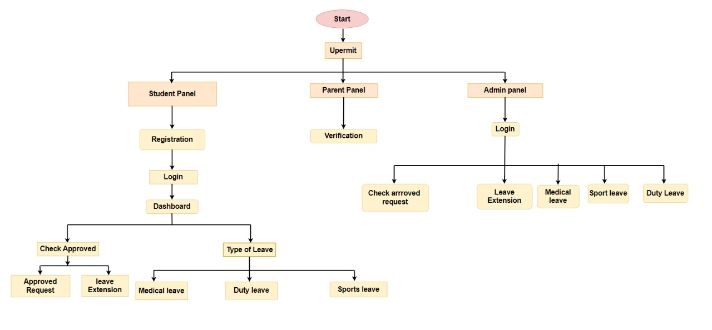

**Figure 1: High Level DFD**

**C) Functional and Performance Specifications**

**Functional Specifications**

**User Roles and Functions:**

* **Students:**

Apply for different leave types (medical, duty, sports) with clear descriptions and supporting documentation requirements.

View their leave history and remaining leave balance .

Request leave extensions.

Track the status of their leave requests.

* **Parents:**

Short OTP validity period (e.g., 5 minutes).

* **Admin Panel:**

Review all submitted leave requests.

View details of each request, including student information, leave type, reason, and requested duration.

Approve or reject leave requests based on defined criteria.

Update the database with approval/rejection status.

Generate reports on leave trends, staff workload, or student attendance patterns (optional).

**Performance Specifications**

* **Response Time:**

The system should respond to user actions (e.g., login, submitting leave requests, viewing leave status) within a reasonable timeframe (e.g., 2-3 seconds).

* **Availability:**

The system should be highly available with minimal downtime. Aim for uptime targets like 99% or higher.

* **Scalability:**

The system should be able to handle an increasing number of users and data volume without significant performance degradation. Consider using cloud-based solutions or scalable architectures to accommodate future growth.

34.

* **Security:**

The system should implement robust security measures to protect user data, including encryption of sensitive information, secure authentication protocols, and regular security audits.

1. Design
   * + 1. Detailed DFD

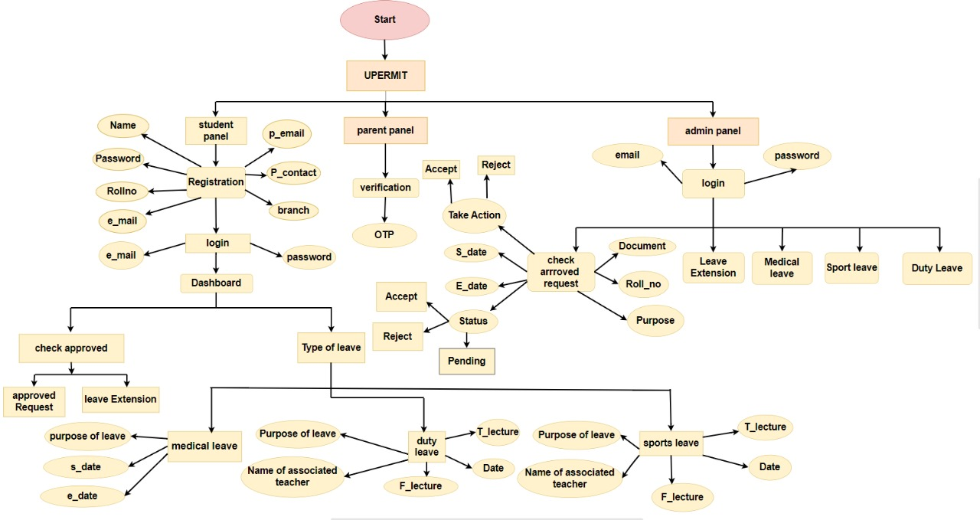

**Figure 2: Detailed DFD**

35.

* + - 1. Filesystems,database 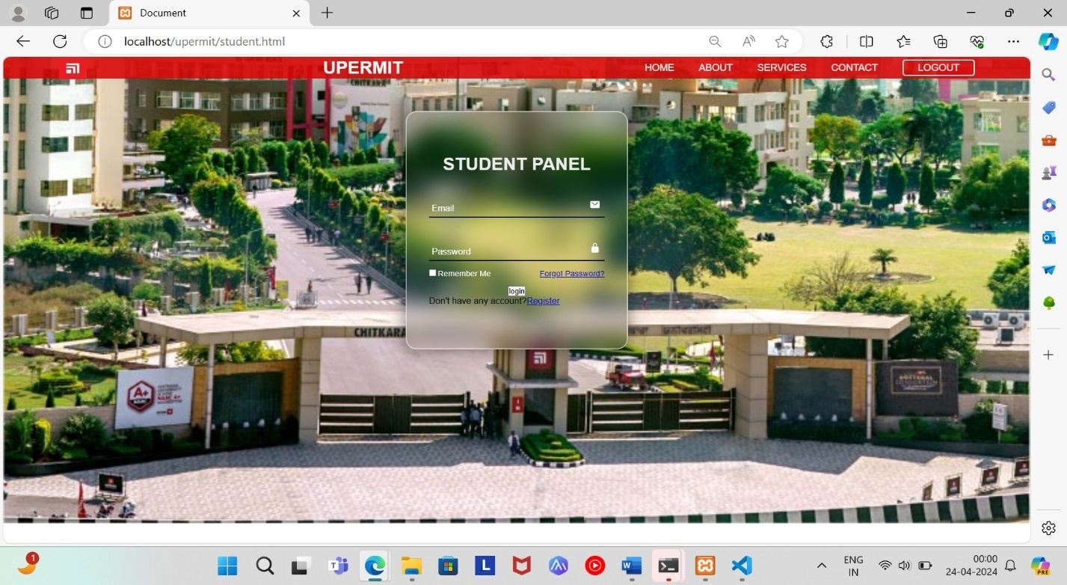

**Figure 3:Student Login Page**

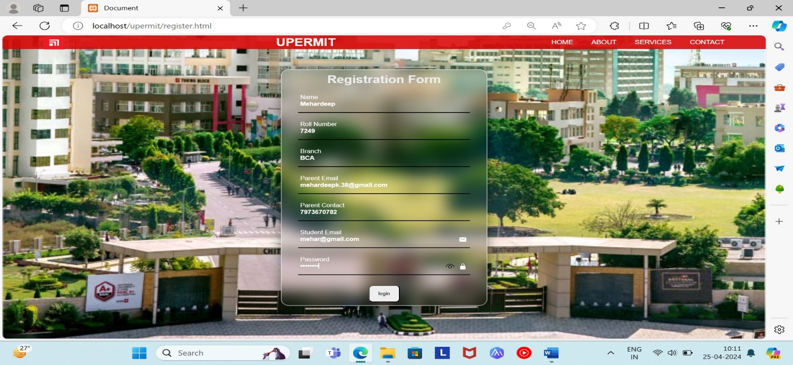

**Figure 4: Registration Form**

36.

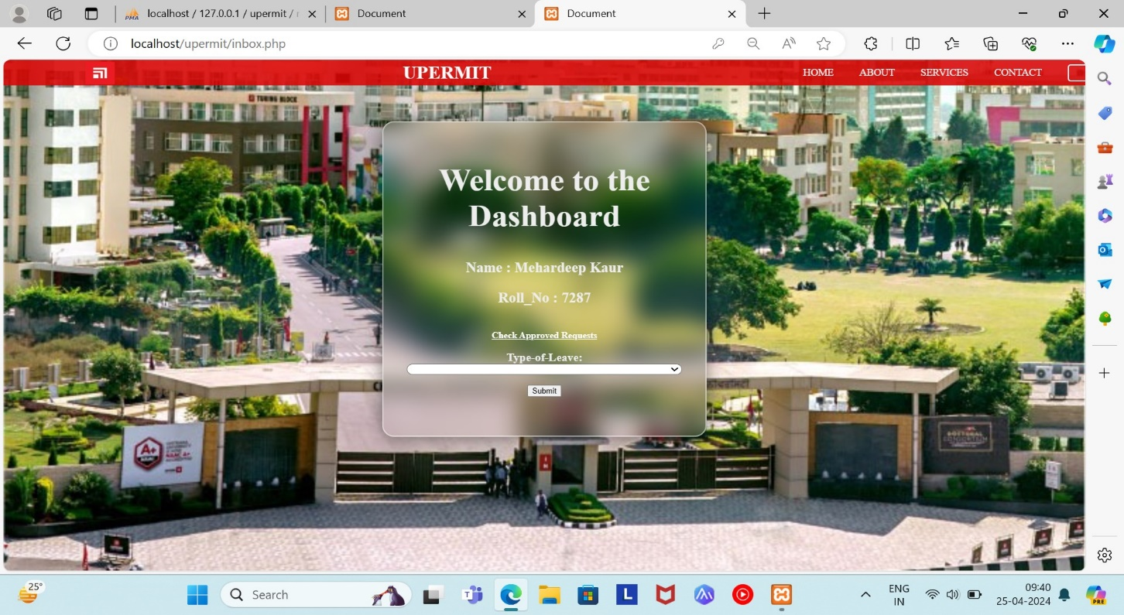

**Figure 5: Student Dashboard**

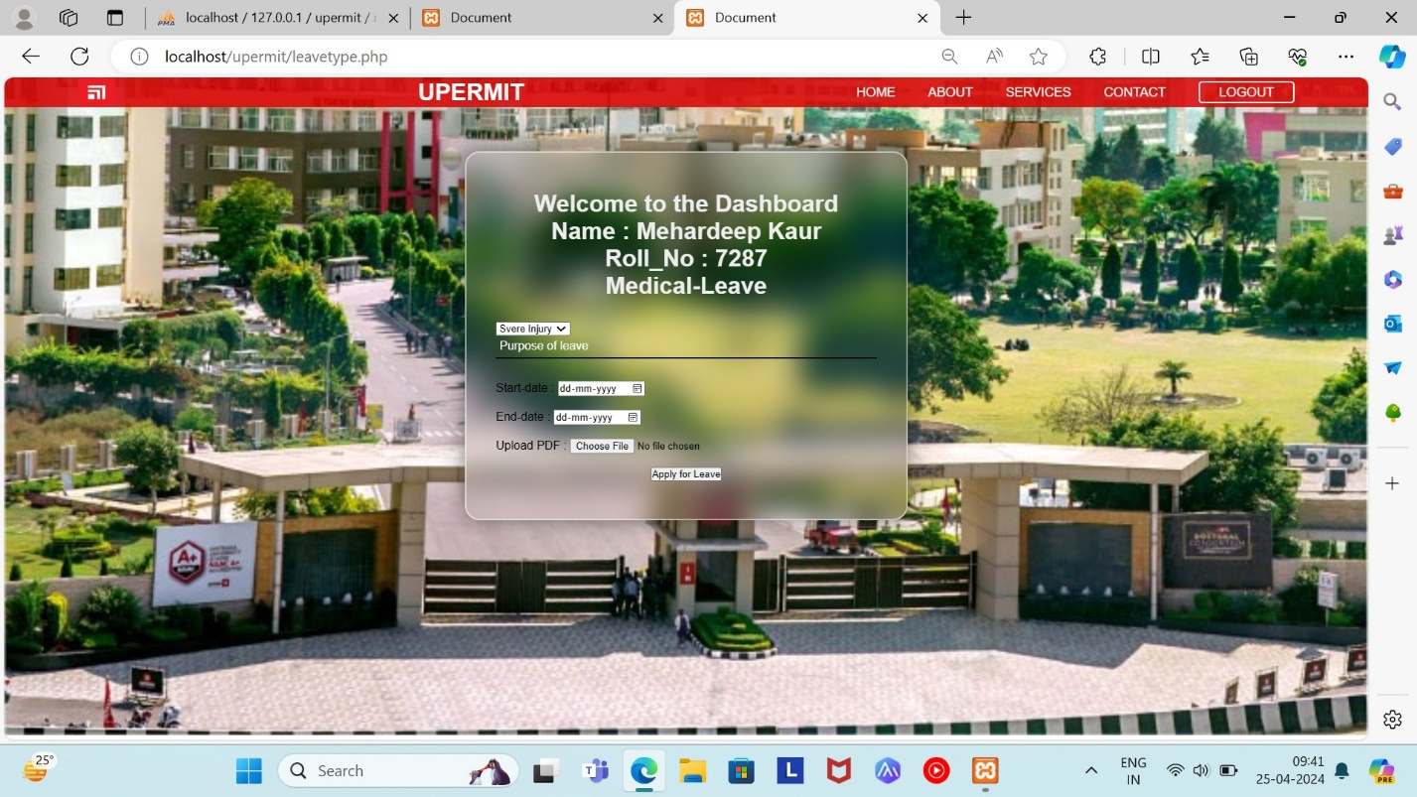

**Figure 6: Dashboard Showing Medical Leave**

37.

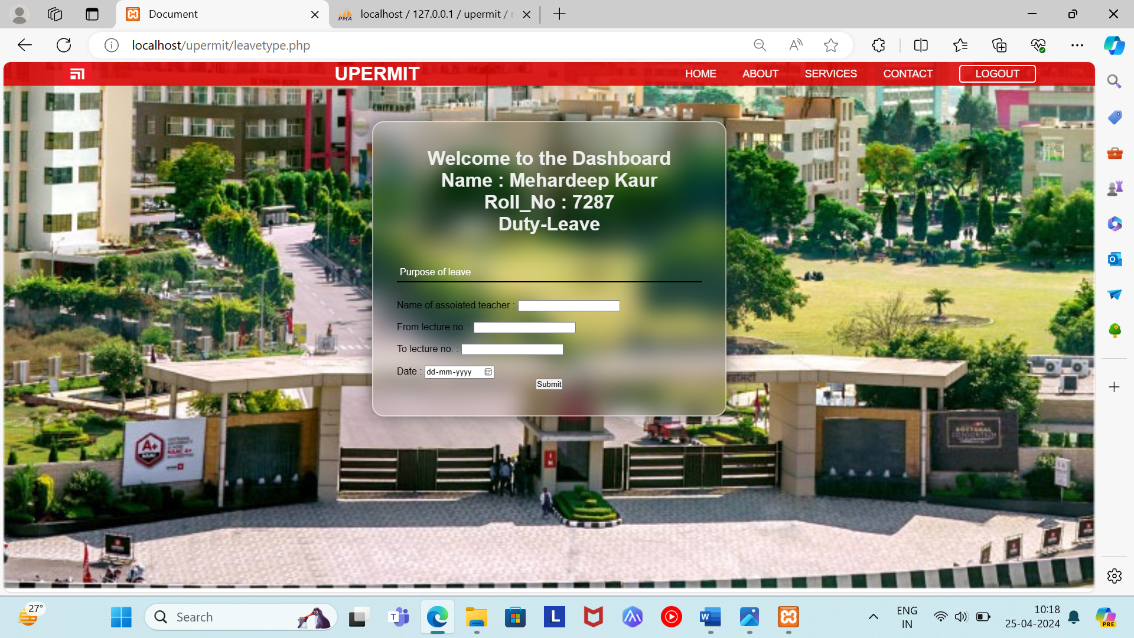

**Figure 7:Dashboard Showing Duty Leave**

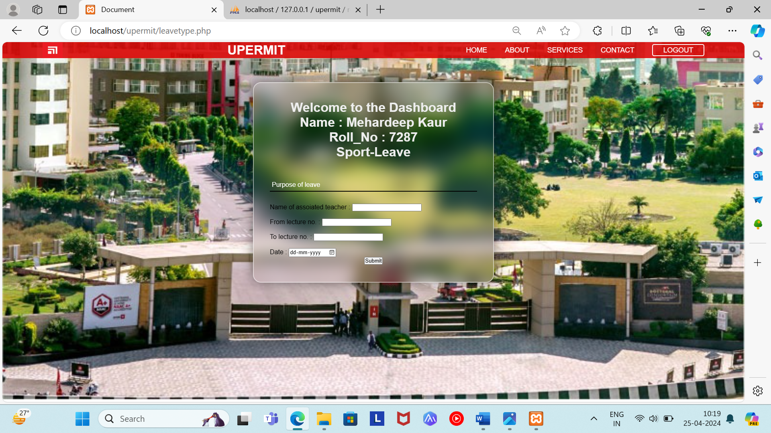

**Figure 8:Dashboard Showing Sport Leave**

38.

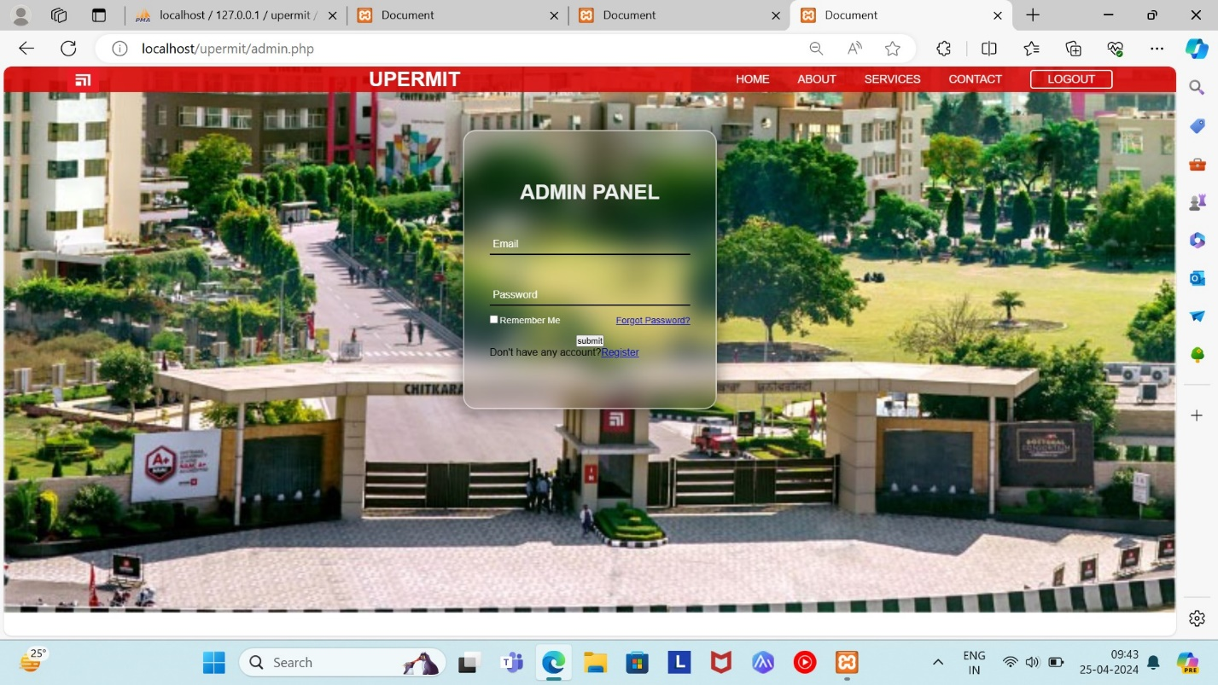

**Figure 9:Admin Login Page**

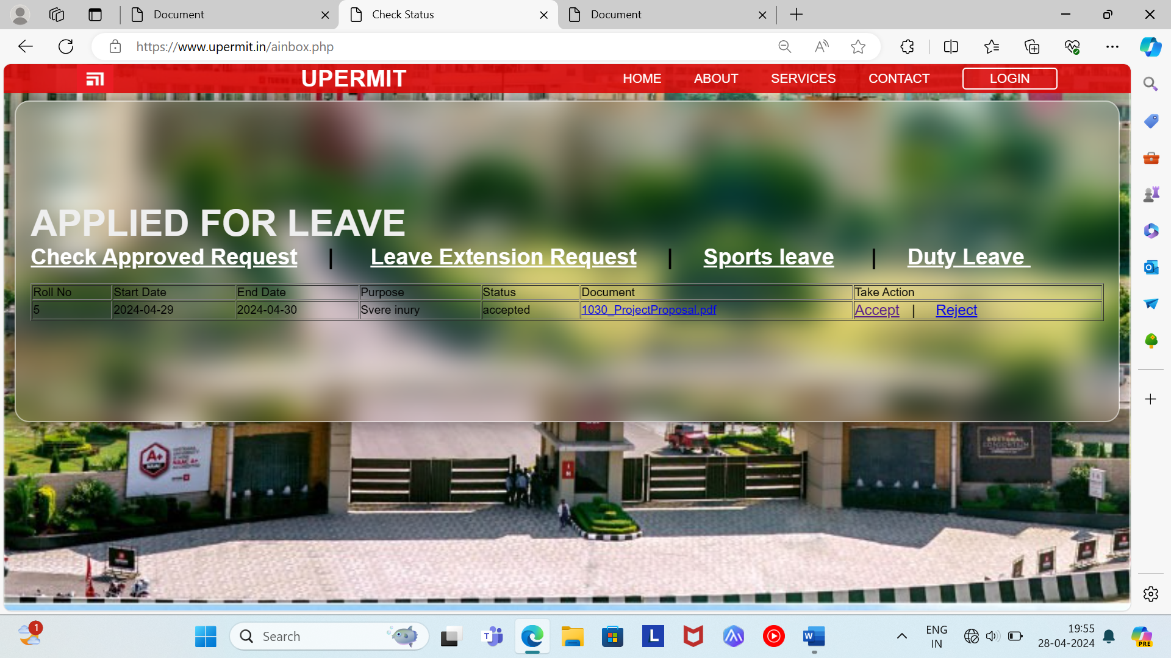

**Figure 10:Checking Leave Request Status**

39.

e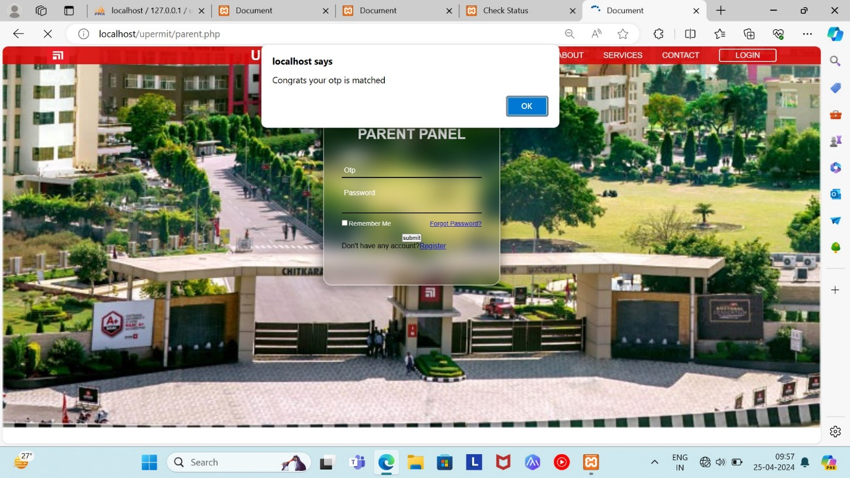

**Figure 11: OTP matched on Parent Panel**

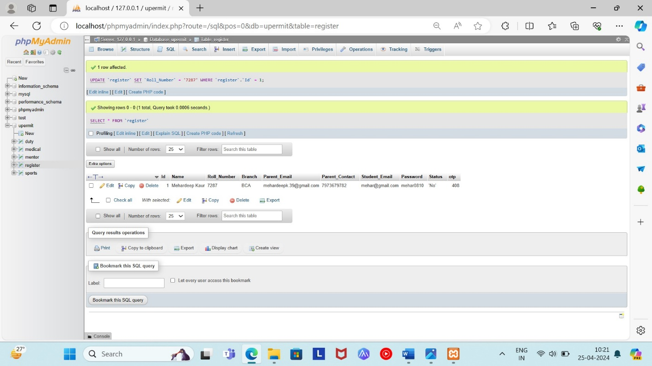

**Figure 12: Database Storing Registration Form Information**

40.

7. Test Plan

Functional Testing:

User Registration:

Verify that students can register with a one-time password (OTP) sent to their parent portal.

Ensure that parents can access the Parent Panel after successful registration.

Leave Application:

Test the ability of students to apply for medical, duty, and sports leaves.

Verify that leave requests include necessary information such as leave type, dates, and reason.

Leave Approval:

Test the Admin Panel's ability to approve or reject leave requests.

Verify that approved leave requests are reflected accurately in the system.

Parent Monitoring:

Ensure parents can view their child's attendance, performance, and participation in extracurricular activities.

Verify that the Excel sheet provided to parents is up-to-date and accurate.

Performance Testing:

Load Testing:

Simulate a high volume of concurrent users accessing the system.

Measure system response times and resource utilization under load.

Scalability Testing:

Test the system's ability to handle increased user load by gradually increasing the number of concurrent users.

Verify that performance remains consistent as the user base grows.

Stress Testing:

Apply stress to the system beyond normal operational capacity.

Monitor system behaviour and identify any points of failure or degradation in performance.

Security Testing:

Authentication:

Test the security of user authentication mechanisms, including OTP verification.

Verify that unauthorized access attempts are detected and prevented.

41.

Data Security:

Ensure that sensitive student and parent data is encrypted both in transit and at rest.

Test for vulnerabilities such as SQL injection, cross-site scripting (XSS), and session hijacking.

Access Control:

Test the system's access control mechanisms to prevent unauthorized access to sensitive functionalities or data.

Usability Testing:

User Interface:

Evaluate the clarity, consistency, and intuitiveness of the user interface across all panels.

Identify any usability issues or areas for improvement based on user feedback.

Accessibility:

Test the accessibility of the system for users with disabilities, including screen readers and keyboard navigation.

**Integration Testing:**

System Integration:

Test the integration between the UPERMIT system and any external systems or databases, such as student information systems or email/SMS services.

Verify that data is synchronized accurately between systems and that functionality is not impacted by integration.

**Regression Testing:**

Test previously implemented functionalities after system updates or changes to ensure that existing features still work as expected.

Identify and resolve any unintended side effects or regressions introduced by updates.

**User Acceptance Testing (UAT):**

Involve end-users in testing to validate that the system meets their requirements and expectations.

Gather feedback from users to identify any issues or areas for improvement before full deployment.

42.

|  |  |
| --- | --- |
| FUNCTIONALITY - 1 | |
| PROJECT NAME | UPERMIT |
| PANEL NAME | STUDENT PANEL |

43.

43.

|  |  |  |  |  |  |  |  |
| --- | --- | --- | --- | --- | --- | --- | --- |
| Scenario TID | Scenario Desciption | Test Case ID | Pre-Condition | Steps to Execute | Expected Result | Actual Result | Status |
| 1 | Successful registered with valid credentials | 1 | The user has valid Registration credentials | 1.Navigate to the registration page.  2.Enter valid credentials  3.Click on the “Submit” button. | The user should be successfully registered into the system and redirected to the login page. | The user was successfully registered into the system and redirected to the login page. | PASS |
| 2 | Login with invalid username and valid password | 2 | The user attempts to log in with an invalid username and valid password. | 1.Navigate to the login page.  2.Enter an invalid username.  3.Enter a valid password.  4.Click on the "Login" button. | The system should display an error message indicating that the username is incorrect. | The system displayed the expected error message indicating that the username is incorrect. | PASS |
| 3 | Login with invalid password and valid username | 3 | The user attempts to log in with an invalid password and valid username. | 1.Navigate to the login page.  2.Enter an invalid password.  3.Enter a valid username.  4.Click on the "Login" button. | The system should display an error message indicating that the password is incorrect. | The system displayed the expected error message indicating that the password is incorrect. | PASS |
| 4 | Login with empty username and password fields | 4 | The user does not enter any input for the username and password fields. | 1.Navigate to the login page.  2.Leave the username and password fields empty.  3.Click on the "Login" button. | The system should display an error message indicating that both the username and password fields are required. | The system displayed the expected error message indicating that both username &password fields are required. | PASS |

|  |  |
| --- | --- |
| FUNCTIONALITY – 2 | |
| PROJECT NAME | UPERMIT |
| PANEL | ADMIN PANEL |

44.

|  |  |  |  |  |  |  |  |
| --- | --- | --- | --- | --- | --- | --- | --- |
| Scenario TID | Scenario Desciption | Test Case ID | Pre-Condition | Steps to Execute | Expected Result | Actual Result | Status |
| 1 | Successful login with valid credentials | 1 | The user has valid login credentials | 1.Navigate to the login page.  2.Enter valid username and password.  3.Click on the “Login” button. | The user should be successfully logged into the system and redirected to the dashboard or homepage. | The user was successfully logged into the system and redirected to the dashboard. | PASS |
| 2 | Login with invalid username | 2 | The user attempts to log in with an invalid username. | 1.Navigate to the login page.  2.Enter an invalid username.  3.Enter a valid password.  4.Click on the "Login" button. | The system should display an error message indicating that the username is incorrect. | The system displayed the expected error message indicating that the username is incorrect. | PASS |
| 3 | Login with invalid password | 3 | The user attempts to log in with an invalid password. | 1.Navigate to the login page.  2.Enter an invalid username.  3.Enter a valid password.  4.Click on the "Login" button. | The system should display an error message indicating that the password is incorrect. | The system displayed the expected error message indicating that the password is incorrect. | PASS |
| 4 | Login with empty username and password fields | 4 | ­­  The user does not enter any input for the username and password fields. | 1.Navigate to the login page.  2.Leave the username and password fields empty.  3.Click on the "Login" button. | The system should display an error message indicating that both the username and password fields are required. | The system displayed the expected error message indicating that both theusername &password fields are required. | PASS |

|  |  |
| --- | --- |
| FUNCTIONALITY – 3 | |
| PROJECT NAME | UPERMIT |
| PANEL | PARENT PANEL |

|  |  |  |  |  |  |  |  |
| --- | --- | --- | --- | --- | --- | --- | --- |
| Scenario TID | Scenario Desciption | Test Case ID | Pre-Condition | Steps to Execute | Expected Result | Actual Result | Status |
| 1 | Successful match with valid OTP | 1 | The Parent has entered valid otp | 1.Navigate to the OTP page.  2.Enter valid password.  3.Click on the “submit” button. | The parent should be successfully entered the valid OTP. | The parent was successfully entered the valid OTP | PASS |

45.

|  |  |
| --- | --- |
| FUNCTIONALITY – 4 | |
| PROJECT NAME | UPERMIT |
| PANEL | Registration Form(Student panel) |

46.

|  |  |  |  |  |  |  |
| --- | --- | --- | --- | --- | --- | --- |
| Scenario TID | Scenario Desciption | Test Case ID | Inputs | Expected Result | Actual Result | Status |
| 1 | Empty Fields | 1 | Empty fields for all form inputs | Error message or form validation for each empty field | [Actual result]. | PASS |
| 2 | Valid Data | 2 | Valid data for all form inputs | Valid data for all form inputs | [Actual result]. | PASS |
| 3 | Invalid Email Formats | 3 | Invalid email formats(e.g,missing “@” symbol) | Error message for invalid email format | [Actual result]. | PASS |
| 4 | Invalid Password | 4 | Short or week password,mismatched passwords. | Error message for invalid password | [Actual result]. | PASS |
| 5 | Invalid Parent  Email | 5 | Invalid parent email format | Error message for invalid parent email | [Actual result]. | PASS |
| 6 | Invalid Roll Number | 6 | Invalid roll number format (e.g., containing special characters)| Error message for invalid roll number | Error message for invalid roll number | [Actual result] | PASS |
| 7 | Branch Selection | 7 | Form submitted without selecting a branch | Error message for branch selection required | [Actual result] | PASS |
| 8 | Invalid Parent Contact | 8 | Invalid parent contact number format (e.g., contains letters) | Error message for invalid parent contact number | [Actual result] | PASS |
| 9 | Duplicate Email/Username | 9 | Duplicate email or username in form submission | Error message for exceeding input limitations | [Actual result] | PASS |
| 10 | Field Limitations | 10 | Input data that exceeds character or size limitation | Error message for exceeding input limitations | [Actual result] | PASS |

47.

|  |  |
| --- | --- |
| FUNCTIONALITY – 5 | |
| PROJECT NAME | UPERMIT |
| PANEL | Login Form(login panel) |

|  |  |  |  |  |  |  |
| --- | --- | --- | --- | --- | --- | --- |
| Scenario TID | Scenario Desciption | Test Case ID | Steps to Execute | Expected Result | Actual Result | Status |
| 1 | Valid login with correct email and password | 1 | 1. Enter valid email  2. Enter valid password  3. Click on login button | User is successfully logged in | [Actual result] | PASS |
| 2 | Invalid login with incorrect email and correct password | 2 | 1. Enter incorrect email  2. Enter correct password  3. Click on login button | Error message displayed (Invalid email) | [Actual result] | PASS |
| 3 | Invalid login with correct email and incorrect password | 3 | 1. Enter correct email  2. Enter incorrect password  3. Click on login button | Error message displayed (Invalid password) | [Actual result] | PASS |
| 4 | Invalid login with empty email and password fields | 4 | 1. Leave email field empty  2. Leave password field empty 3. Click on login button | Error message displayed (Email required) | [Actual result] | PASS |
| 5 | Invalid login with valid email and empty password field | 5 | 1. Enter valid email  2. Leave password field empty 3. Click on login button | Error message displayed (Password required) | [Actual result] | PASS |
| 6 | Invalid login with empty email and valid password field | 6 | 1. Leave email field empty  2. Enter valid password  3. Click on login button | Error message displayed (Email required) | [Actual result] | PASS |
| 7 | Invalid login with incorrect email format | 7 | 1. Enter invalid email format 2. Enter valid password 3. Click on login button | Error message displayed (Invalid email format) | [Actual result] | PASS |

48.

|  |  |
| --- | --- |
| FUNCTIONALITY – 6 | |
| PROJECT NAME | UPERMIT |
| PANEL | Dashboard(student panel) |

49.

|  |  |  |  |  |  |  |
| --- | --- | --- | --- | --- | --- | --- |
| Scenario TID | Scenario  Desciption | Test Case ID | Steps to Execute | Expected Result | Actual Result | Status |
| 1 | Verify Student Information Display | 1 | 1. Log into dashboard page | Name and roll number of the student are correctly displayed | [Actual result] | PASS |
| 2 | Check Status Link Functionality | 2 | 1. Click on "Check Status" link | Redirected to status page displaying current leave status | [Actual result] | PASS |
| 3 | Leave Extension Link Functionality | 3 | 1. Click on "Leave Extension" link | Redirected to leave extension page for applying for extension | [Actual result] | PASS |
| 4 | Leave Type Display | 4 | 1. Check type of leave displayed | Correct type of leave (e.g., sick leave) is displayed | [Actual result] | PASS |
| 5 | Empty Dashboard Handling | 5 | 1. No leave requests available | Dashboard displays "No leave requests currently" message | [Actual result] | PASS |
| 6 | Link Navigation | 6 | 1. Click on various links multiple times | Links navigate correctly without errors | [Actual result] | PASS |
| 7 | Leave Extension Form Validation | 7 | 1. Fill out leave extension form with invalid data | Proper validation messages displayed | [Actual result] | PASS |
| 8 | Leave Status Update | 8 | 1. Submit leave extension request | Status page updates to reflect new leave extension request | [Actual result] | PASS |
| 9 | Multiple Leave Requests Handling | 9 | 1. Student has multiple leave requests | Dashboard displays all leave requests with details | [Actual result] | PASS |
| 10 | Security Testing | 10 | 1. Attempt to access without authentication | Access denied message or redirection to login page | [Actual result] | PASS |

|  |  |
| --- | --- |
| FUNCTIONALITY – 7 | |
| PROJECT NAME | UPERMIT |
| PANEL | check approved request page |

50.

51.

|  |  |  |  |  |  |  |
| --- | --- | --- | --- | --- | --- | --- |
| Scenario  TID | Scenario  Desciption | Test Case ID | Steps to Execute | Expected Result | Actual Result | Status |
| 1 | Verify "Take Action" button for "Pending" requests | 1 | 1. Navigate to "Check Approved Request" page.  2. Identify a request with status "Pending."  3. Check if "Take Action" button is enabled. | The "Take Action" button should be enabled for "Pending" requests. | The "Take Action" button is enabled for "Pending" requests. | PASS |
| 2 | Verify display of start and end dates | 2 | 1. Navigate to "Check Approved Request" page.  2. Select an approved request. 3. Verify start and end dates. | Start date and end date are displayed correctly for the selected request. | Start date and end date are displayed correctly for the selected request. | PASS |
| 3 | Verify document upload and display | 3 | 1. Navigate to "Check Approved Request" page.  2. Select an approved request.  3. Upload a document (e.g., PDF file).  4. Verify document display. | The uploaded document should be displayed with the approved request. | The uploaded document is displayed with the approved request. | PASS |
| 4 | Verify status field update after action | 4 | 1. Navigate to "Check Approved Request" page.  2. Select a "Pending" request. 3. Click "Approve" button.  4. Verify status field update | The status field should update to "Approved" after taking action. | The status field updates to "Approved" after taking action. | PASS |
| 5 | Test for SQL injection in roll number field | 5 | 1. Navigate to "Check Approved Request" page.  2. Enter malicious SQL query in roll number field.  3. Submit form. | The application should detect SQL injection and display an error. | [Actual result] | PASS |
| 6 | Test page loading time with large dataset | 6 | 1. Populate system with a large number of approved requests.  2. Navigate to "Check Approved Request" page.  3. Measure page loading time | The page should load within an acceptable time frame with large data. | The page loads within an acceptable time frame with large data. | PASS |

51.

|  |  |
| --- | --- |
| FUNCTIONALITY – 8 | |
| PROJECT NAME | UPERMIT |
| PANEL | Otp verification(parent panel) |

|  |  |  |  |  |  |  |
| --- | --- | --- | --- | --- | --- | --- |
| Scenario  TID | Scenario  Desciption | Test Case ID | Steps to Execute | Expected Result | Actual Result | Status |
| 1 | Valid OTP - Correct 6-digit OTP | 1 | Enter 123456 in OTP field | OTP verified successfully | OTP verified successfully | PASS |
| 2 | Valid OTP - Random 6-digit OTP | 2 | Enter 987654 in OTP field | OTP verified successfully | OTP verified successfully | PASS |
| 3 | Invalid OTP - Less than 6 digits | 3 | Enter 12345 in OTP field | Error message: "Invalid OTP" | Error message: "Invalid OTP" | PASS |
| 4 | Invalid OTP - More than 6 digits | 4 | Enter 1234567 in OTP field | Error message: "Invalid OTP" | Error message: "Invalid OTP" | PASS |
| 5 | Invalid OTP - Alphanumeric OTP | 5 | Enter abcdef in OTP field | Error message: "Invalid OTP" | Error message: "Invalid OTP" | PASS |
| 6 | Invalid OTP - Special characters in OTP | 6 | Enter 12@#45 in OTP field | Error message: "Invalid OTP" | Error message: "Invalid OTP" | PASS |
| 7 | Empty Field - Leaving OTP field blank | 7 | Leave OTP field blank | Error message: "Please enter OTP" | Error message: "Please enter OTP" | PASS |
| 8 | Empty Field - Entering only spaces in OTP | 8 | Enter only spaces in OTP field | Error message: "Please enter OTP" | Error message: "Please enter OTP" | PASS |

52.

|  |  |
| --- | --- |
| FUNCTIONALITY - 9 | |
| PROJECT NAME | UPERMIT |
| PANEL NAME | Login page(Admin PANEL) |

53.

|  |  |  |  |  |  |  |  |
| --- | --- | --- | --- | --- | --- | --- | --- |
| Scenario TID | Scenario Desciption | Test Case ID | Pre-Condition | Steps to Execute | Expected Result | Actual Result | Status |
| 1 | Successful registered with valid credentials | 1 | The user has valid Registration credentials | 1.Navigate to the registration page.  2.Enter valid credentials  3.Click on the “Submit” button. | The user should be successfully registered into the system and redirected to the login page. | The user was successfully registered into the system and redirected to the login page. | PASS |
| 2 | Login with invalid username and valid password | 2 | The user attempts to log in with an invalid username and valid password. | 1.Navigate to the login page.  2.Enter an invalid username.  3.Enter a valid password.  4.Click on the "Login" button. | The system should display an error message indicating that the username is incorrect. | The system displayed the expected error message indicating that the username is incorrect. | PASS |
| 3 | Login with invalid password and valid username | 3 | The user attempts to log in with an invalid password and valid username. | 1.Navigate to the login page.  2.Enter an invalid password.  3.Enter a valid username.  4.Click on the "Login" button. | The system should display an error message indicating that the password is incorrect. | The system displayed the expected error message indicating that the password is incorrect. | PASS |
| 4 | Login with empty username and password fields | 4 | ­The user does not enter any input for the username and password fields. | 1.Navigate to the login page.  2.Leave the username and password fields empty.  3.Click on the "Login" button. | The system should display an error message indicating that both the username and password fields are required. | The system displayed the expected error message indicating that both the username &password fields are required. | PASS |

**TEST REPORT**

54.

|  |  |  |  |  |  |  |  |  |  |  |  |  |  |  |  |  |  |  |  |  |  |  |  |  |  |  |  |  |  |  |  |  |  |
| --- | --- | --- | --- | --- | --- | --- | --- | --- | --- | --- | --- | --- | --- | --- | --- | --- | --- | --- | --- | --- | --- | --- | --- | --- | --- | --- | --- | --- | --- | --- | --- | --- | --- |
| Executed | | | Passed | | | | | 45 | | | | | | |  | | |  | | |  | | |  | | |  | | |  | | | |
|  | | | Failed | | | | | 0 | | | | | | |  | | |  | | |  | | |  | | |  | | |  | | | |
|  | | | (Total)Testes Executed (Passed +Failed) | | | | | | | |  | | | |  | | |  | | |  | | |  | | |  | | |  | | | |
| Pending | | | | | | | |  | | |  | | | |  | | |  | | |  | | |  | | |  | | |  | | | |
| In Progress | | | | | | | |  | | |  | | | |  | | |  | | |  | | |  | | |  | | |  | | | |
| Blocked | | | | | | | |  | | |  | | | |  | | |  | | |  | | |  | | |  | | |  | | | |
| (Sub-Total) Test Planed | | | | | | | |  | | |  | | | |  | | |  | | |  | | |  | | |  | | |  | | | |
| Pending + In Progress + Blocked + Test Executes | | | | | | | |  | | |  | | | |  | | |  | | |  | | |  | | |  | | |  | | | |
| **FUNCTION** | | | | | | **DESCRIPTION** | | | | | **%TCs executed** | | **%TCs Passed** | | | | | | | | | | | **TCs pending** | | | | | | **Priority** | | |
|
| Student Register | | | | | | Verify that users with student credentials can successfully Register in to the system. | | | | | 100% | | 100% | | | | | | | | | | | 0 | | | | | | High | | |
| Student login | | | | | | Verify that users with student credentials can successfully Login into the system. | | | | | 100% | | 100% | | | | | | | | | | | 0 | | | | | | High | | |
| Leave apply | | | | | | Verify the functionality for students to Apply for Leave. | | | | | 100% | | 100% | | | | | | | | | | | 0 | | | | | | High | | |
| Check Approve Request | | | | | | Verify the functionality to check the approval request. | | | | | 100% | | 100% | | | | | | | | | | | 0 | | | | | | High | | |
| Admin login | | | | | | Verify that users with teacher credentials can successfully log in to the system. | | | | | 100% | | 100% | | | | | | | | | | | 0 | | | | | | High | | |
| Approve Request | | | | | | Verify the functionality for teachers to approve the request. | | | | | 100% | | 100% | | | | | | | | | | | 0 | | | | | | High | | |
|  | | |  | | |  | |  | | |  | | | |  | | |  | | |  | | |  | | |  | | |  | | |
|  | | |  | | |  | |  | | |  | | | |  | | |  | | |  | | |  | | |  | | |  | | |
|  | | |  | | |  | |  | | |  | | | |  | | |  | | |  | | |  | | |  | | |  | | |
|  | |  | | |  | |  | | |  | | | |  | | |  | | |  | | |  | | |  | | |  | | |  | |
|  | |  | | |  | |  | | |  | | | |  | | |  | | |  | | |  | | |  | | |  | | |  | |

|  |  |  |  |  |  |
| --- | --- | --- | --- | --- | --- |
| Reject Request | Verify the functionality for teachers to Reject the request. | 100% | 100% | 0 | High |
| OTP Verification | Verify the OTP for Registration. | 100% | 100% | 0 | High |

8. Implementation/ Conversion Plan:

**Planning Phase**

Establishment of Project Team:

- The project team will consist of representatives from various departments including IT, administration, and end-users.

- IT representatives will handle system configuration and integration.

- Administration members will oversee budgeting, timeline, and project management.

- End-users will provide insights into their needs and requirements for the system.

Definition of Project Objectives:

- The primary objective of the UPERMIT project is to streamline the leave management process across the university.

- Secondary objectives include improving transparency, efficiency, and user experience.

- Scope will include the development and implementation of a web-based leave management system with separate panels for students, parents, and administrators.

55.

Identification of Key Stakeholders:

- Key stakeholders will include faculty, administrative staff, students, parents, and IT support staff.

- Each stakeholder group will have specific roles and responsibilities in the implementation process.

- Faculty and administrative staff will provide input on system requirements.

- Students and parents will be end-users of the system.

- IT support staff will handle system configuration, integration, and maintenance.

Analysis of Existing Processes:

- A thorough analysis of existing leave management processes will be conducted to identify pain points and areas for improvement.

- Interviews, surveys, and process mapping will be used to gather information.

- Common challenges such as manual paperwork, lack of visibility, and communication gaps will be addressed in the new system design.

**System Configuration**

Customization of UPERMIT System:

- The UPERMIT system will be customized to meet the specific needs of the university.

- Customization will include defining leave types, approval workflows, and user roles.

- Different leave types such as sick leave, vacation leave, and study leave will be configured.

- Approval workflows will be established based on hierarchical structures within departments.

- User roles will be defined for students, parents, faculty, and administrative staff with appropriate permissions.

Integration with Existing Systems:

- The UPERMIT system will be integrated with existing university systems such as student databases and authentication systems.

- Integration will ensure seamless data flow between systems, reducing manual data entry and potential errors.

- Single sign-on (SSO) functionality will be implemented to allow users to access the UPERMIT system using their existing university credentials.

56.

- Data synchronization mechanisms will be put in place to keep information up-to-date across systems.

**Data Migration**

Transfer of Existing Records:

- Existing leave records and student information will be migrated from legacy systems to the UPERMIT system.

- Data migration tools and scripts will be used to facilitate the transfer process.

- Historical leave data will be preserved for reference and reporting purposes.

- Data migration will be conducted in phases to minimize disruption to ongoing operations.

Ensuring Data Integrity:

- Measures will be taken to ensure the integrity and accuracy of data throughout the migration process.

- Data validation checks will be performed to identify and resolve any discrepancies.

- Data cleansing activities will be undertaken to eliminate duplicate or obsolete records.

Backups of data will be created before and after migration to mitigate the risk of data loss.

Development of Contingency Plans:

- Contingency plans will be developed to address potential issues or errors encountered during data migration.

- Strategies for data rollback, manual intervention, and communication protocols will be outlined.

- A dedicated support team will be on standby to address any issues in real-time.

- Regular checkpoints will be established to monitor progress and identify any deviations from the migration plan.

**Testing and Quality Assurance**

Comprehensive Testing Approach:

- A comprehensive testing strategy will be adopted to ensure the reliability and functionality of the UPERMIT system.

- Testing will encompass functional, performance, security, and usability aspects.

57

- Test cases will be developed to cover various scenarios and use cases.

- Testing will be conducted iteratively throughout the development lifecycle to identify and address issues early on.

Involvement of End-Users:

- End-users will be actively involved in the testing process through User Acceptance Testing (UAT).

- UAT sessions will be conducted to validate system functionality and gather feedback from stakeholders.

- Feedback from end-users will be incorporated into the system design to enhance usability and user experience.

- Test results and feedback will be documented and analyzed to prioritize and address issues.

**Training and Documentation**

Development of Training Materials:

- Training materials will be developed to support end-users in using the UPERMIT system effectively.

- Materials will include user guides, tutorials, and video demonstrations.

- Training content will be tailored to the specific needs of different user groups such as students, parents, and administrators.

- Training materials will be made available online for easy access and reference.

Training Sessions for Users:

- Training sessions will be conducted for administrators, staff, students, and parents to familiarize them with the UPERMIT system.

- Sessions will cover system navigation, leave request submission, approval workflows, and access to relevant information.

- Training sessions will be interactive, allowing users to ask questions and practice using the system in a simulated environment.

- Multiple training sessions will be scheduled to accommodate different schedules and preferences.

58.

Ongoing Support and Resources:

- Ongoing support and resources will be provided to users to troubleshoot any issues or questions they may encounter.

- Helpdesk support will be available via phone, email, and online chat.

- Frequently Asked Questions (FAQs) and knowledge base articles will be published to address common queries.

- Regular updates and announcements will be communicated to users to keep them informed about system changes and enhancements.

**Communication and Change Management**

Benefits Communication:

- The benefits of the UPERMIT system will be communicated to stakeholders through various channels.

- Benefits such as improved efficiency, transparency, and accessibility will be highlighted.

- Case studies and success stories from pilot implementations will be shared to illustrate the impact of the system.

- Communication efforts will emphasize the value proposition of the UPERMIT system in addressing current challenges and improving overall operations.

Regular Updates on Implementation Progress:

- Regular updates on the implementation progress will be provided to stakeholders through newsletters, emails, and project status reports.

- Milestones achieved, challenges encountered, and upcoming milestones will be communicated transparently.

- Open channels for feedback will be maintained to address any concerns or questions from stakeholders.

- Transparency in communication will foster trust and engagement among stakeholders throughout the implementation process.

Proactive Addressing of Concerns:

- Concerns or resistance to change from stakeholders will be proactively addressed through targeted communication and engagement strategies.

- Listening sessions, focus groups, and town hall meetings will be organized to gather input and address concerns.

59.

- Change champions will be identified and empowered to advocate for the UPERMIT system within their respective departments or user groups.

- Feedback mechanisms will be established to ensure that stakeholder concerns are acknowledged and addressed in a timely manner.

**Pilot Rollout**

Pilot Rollout Strategy:

- A pilot rollout of the UPERMIT system will be conducted with a smaller group of users or in a specific department or division.

- Pilot users will be selected to represent a diverse range of roles and use cases.

- The pilot rollout will serve as a testbed to validate system functionality, identify potential issues, and gather feedback for improvements

.

- Regular check-ins and feedback sessions will be conducted with pilot users to monitor their experience and address any issues encountered.

Feedback Collection and Analysis:

- Feedback from pilot users will be collected through surveys, interviews, and focus groups.

- Feedback will be analyzed to identify common themes, pain points, and suggestions for improvement.

- Feedback will be categorized based on severity and priority for action.

- Action plans will be developed to address identified issues and incorporate feedback into the system design before full deployment.

**Full Deployment**

Rollout to All Users:

- Following the successful completion of the pilot rollout, the UPERMIT system will be rolled out to all users across the university.

- Rollout activities will be carefully planned and coordinated to minimize disruption to ongoing operations.

- Training sessions and support resources will be provided to prepare users for the transition to the new system.

- Communication efforts will be intensified to ensure that all users are informed about the rollout schedule, changes, and support options available.

60.

Monitoring and Issue Resolution:

- System performance and user feedback will be closely monitored during the initial rollout phase.

- Dedicated support channels will be available to address any issues or challenges encountered by users.

- A feedback loop will be established to gather real-time feedback from users and address issues promptly.

- Regular checkpoints will be scheduled to assess the effectiveness of the rollout and identify areas for improvement.

**Evaluation and Optimization**

Post-Deployment Monitoring:

- Usage and effectiveness of the UPERMIT system will be monitored continuously post-deployment.

- Key performance indicators (KPIs) such as user adoption rates, system uptime, and user satisfaction scores will be tracked.

- Analytics tools will be used to analyze usage patterns and identify areas for optimization.

- Regular reports will be generated to provide insights into system performance and inform decision-making.

Feedback Collection from Users:

- Feedback from users will be collected through surveys, feedback forms, and user forums.

- Feedback will be solicited at regular intervals to capture ongoing user experiences and evolving needs.

- Feedback will be analyzed to identify trends, pain points, and opportunities for improvement.

- User feedback will be prioritized and incorporated into the system roadmap for future enhancements.

61.

Opportunities for Optimization:

- Opportunities for optimization and enhancements will be identified based on user feedback, usage data, and emerging trends.

- Iterative improvements will be prioritized based on their impact on user experience, efficiency, and system performance.

- Quick wins and low-hanging fruit will be addressed first to deliver immediate value to users.

- Longer-term initiatives will be planned and prioritized to address more complex challenges and strategic objectives.

**Conclusion and Next Steps**

Summary of Implementation Plan:

- The implementation plan for the UPERMIT system has been outlined with a focus on key activities and considerations across various phases.

- Each phase of the implementation plan is designed to ensure the successful deployment and adoption of the UPERMIT system across the university.

- Collaboration among stakeholders, proactive communication, and a focus on user experience are critical success factors for the implementation.

Next Steps:

- Following the completion of the implementation plan, the focus will shift to ongoing support, maintenance, and optimization of the UPERMIT system.

- Regular reviews and assessments will be conducted to evaluate the effectiveness of the system and identify opportunities for further improvement.

- Continuous engagement with users and stakeholders will be maintained to ensure that the UPERMIT system evolves to meet changing needs and requirements.

- The implementation of the UPERMIT system marks a significant milestone in modernizing leave management processes at the university and lays the foundation for future innovation and improvement.

62.

9. Project Legacy :

1. **Current Status of Project**

Implementation Phase Overview:

- The UPERMIT project has transitioned into the implementation phase, marking a significant milestone in the development journey. With the completion of the Student Panel, Parent Panel, and Admin Panel, the system is now operational and ready for use by the university community.

- The Student Panel offers a comprehensive platform for students to manage their leave requests, view their academic schedule, and access relevant resources. Through intuitive user interfaces and streamlined workflows, students can easily submit leave applications, track their leave history, and receive notifications on the status of their requests.

- Similarly, the Parent Panel provides parents with a convenient way to monitor their child's academic performance and attendance. Parents can view their child's leave requests, attendance records, and academic progress, allowing for better engagement and support.

- The Admin Panel empowers administrators with the tools to manage and oversee the leave management process efficiently. Administrators can review and approve leave requests, generate reports, and configure system settings to align with the university's policies and procedures.

1. **Remaining Areas of Concern:**

User Feedback and Iteration:

- While the initial feedback from users has been positive, it is essential to establish mechanisms for continuous feedback collection and iteration. Regular surveys, feedback forms, and user forums can provide valuable insights into user preferences, pain points, and areas for improvement. By actively soliciting feedback and incorporating user input into future iterations of the system, we can ensure that UPERMIT remains responsive to the evolving needs of students, parents, and administrators.

63.

Technical Stability and Scalability:

- As the user base grows and system usage increases, ensuring the stability and scalability of the UPERMIT system becomes increasingly important. Ongoing performance optimization, load testing, and capacity planning are necessary to maintain system reliability and responsiveness. By monitoring system performance metrics, identifying bottlenecks, and addressing them proactively, we can ensure that UPERMIT can effectively support the needs of all users, even during periods of peak usage.

Data Security and Privacy:

- Protecting sensitive student and parent data is a top priority for the UPERMIT project. Regular audits and updates to security protocols are essential to mitigate potential vulnerabilities and ensure compliance with data protection regulations. By implementing robust data encryption, access controls, and user permissions, we can safeguard the confidentiality and integrity of student and parent information, building trust and confidence in the UPERMIT system.

**c. Technical and Managerial Lessons Learned**

Agile Development:

- Throughout the development process, we have learned the value of adopting agile methodologies such as Scrum or Kanban. Agile development practices emphasize iterative development, collaboration, and flexibility, allowing us to respond quickly to changing requirements and priorities. By breaking down the development process into manageable sprints and regularly reviewing progress with stakeholders, we can ensure that UPERMIT remains aligned with user needs and project goals.

Clear Communication:

- Effective communication has been critical to the success of the UPERMIT project. Regular meetings, status updates, and documentation have helped keep team members, stakeholders, and end-users informed and engaged throughout the development process. By maintaining open channels of communication and proactively addressing any concerns or issues that arise, we can foster collaboration and ensure that everyone involved in the project is working towards a common goal.

64.

User-Centric Design:

- Prioritizing user experience and usability has been a guiding principle in the development of UPERMIT. By conducting user research, prototyping, and usability testing, we have been able to design a system that is intuitive, easy to use, and meets the needs of our diverse user base. Moving forward, we will continue to place a strong emphasis on user-centric design principles, ensuring that UPERMIT remains user-friendly and accessible to all users.

Change Management:

- Managing change effectively has been essential, especially during the transition from manual to automated leave management processes. Providing comprehensive training, support, and guidance to users has helped minimize resistance to change and maximize adoption rates. By fostering a culture of continuous learning and improvement, we can ensure that users feel empowered to embrace new technologies and processes, driving the success of the UPERMIT project.

**d. Future Recommendations**

Integration with Other Systems:

- Exploring opportunities to integrate UPERMIT with other university systems such as SIS, LMS, or HR systems can enhance data accuracy and streamline workflows. Seamless integration allows for the seamless flow of information between systems, reducing manual data entry and potential errors. By leveraging APIs and standardized data formats, we can facilitate interoperability and create a more cohesive and efficient ecosystem of university systems.

65.

Analytics and Reporting:

- Implementing analytics and reporting features within UPERMIT can provide valuable insights into leave data, attendance patterns, and staff workload. By analyzing this data, administrators can make informed decisions about resource allocation, identify trends and patterns, and optimize the efficiency of leave management processes. By empowering administrators with actionable insights, UPERMIT can become a valuable tool for driving strategic decision-making and improving overall organizational performance.

Mobile Accessibility:

- Enhancing the accessibility of UPERMIT through the development of mobile applications or optimization of the existing interface for mobile devices can improve usability and convenience for users. Mobile accessibility allows users to access UPERMIT anytime, anywhere, from their mobile devices, enabling greater flexibility and responsiveness. By prioritizing mobile accessibility, we can cater to the needs of users who prefer to access the system on-the-go, increasing user satisfaction and engagement.

Continuous Improvement:

- Emphasizing a culture of continuous improvement is essential for the long-term success of UPERMIT. By monitoring system performance, soliciting feedback from users, and prioritizing enhancements based on user needs and business objectives, we can ensure that UPERMIT remains relevant, effective, and aligned with the evolving needs of the university community. By embracing change and innovation, we can continue to drive value and deliver exceptional experiences for all users of the UPERMIT system.

Analytics and Reporting:

- Analytics and reporting play a crucial role in driving data-driven decision-making within universities. By leveraging data insights from systems like UPERMIT, administrators can make informed decisions to optimize resources, improve processes, and enhance overall organizational performance. Here's why analytics and reporting are important, along with examples of insights and potential reporting features for UPERMIT:

66.

Importance of Analytics and Reporting:

1. Optimizing Resources:

Analytics can provide insights into leave patterns, helping administrators allocate resources more effectively. By analyzing leave data, administrators can identify peak leave periods, understaffed departments, and trends in leave types. This information enables better resource planning and staffing adjustments to ensure adequate coverage during busy periods.

1. Improving Processes:

Analytics can reveal inefficiencies in leave management processes, such as bottlenecks in approval workflows or excessive administrative burdens. By analyzing process metrics, administrators can identify areas for improvement and implement changes to streamline processes, reduce turnaround times, and enhance user experience.

1. Enhancing Compliance:

Analytics can help ensure compliance with leave policies and regulations. By monitoring leave data, administrators can identify instances of policy violations or discrepancies and take corrective actions to enforce policy adherence. This proactive approach minimizes compliance risks and ensures that leave management practices align with organizational policies and legal requirements.

1. Enhancing Employee Satisfaction:

Analytics can provide insights into employee satisfaction and engagement levels. By analyzing leave data alongside other employee feedback metrics, administrators can identify trends in employee satisfaction, identify areas for improvement, and implement initiatives to enhance employee morale and retention.

67.

Examples of Insights:

1. Leave Data Analysis:

By analyzing leave data, administrators can identify patterns in leave usage, such as seasonal variations, common reasons for leave, and patterns in leave duration. For example, administrators may discover that a particular department experiences higher leave rates during exam periods or that certain types of leave, such as sick leave, are more prevalent during flu seasons.

1. Attendance Patterns:

Attendance data can reveal patterns in employee attendance, such as late arrivals, frequent absences, or patterns of unauthorized leave. For example, administrators may discover that a specific department has higher absenteeism rates on Mondays or that certain employees consistently arrive late.

1. Staff Workload Analysis:

By analyzing leave data alongside workload metrics, administrators can gain insights into staff workload distribution and identify workload imbalances. For example, administrators may discover that certain staff members are consistently overburdened with work, leading to burnout and decreased productivity.

Potential Reporting Features and Visualization Tools for UPERMIT:

1. Dashboard Overview:

A dashboard providing an overview of key leave metrics, such as leave balances, leave approvals, and leave trends over time. This allows administrators to quickly assess the current state of leave management and identify areas that require attention.

68.

1. Leave Usage Reports:

Detailed reports on leave usage by department, employee, leave type, and time period. These reports enable administrators to track leave trends, identify patterns, and forecast future leave demand.

1. Approval Workflow Analysis:

Reports on leave approval workflows, including average approval times, bottlenecks, and rejections. This helps identify inefficiencies in the approval process and streamline workflow management.

1. Attendance Analysis:

Reports on attendance patterns, including absenteeism rates, tardiness, and patterns of unauthorized leave. Visualization tools such as heatmaps and trend charts can highlight patterns and anomalies in attendance data.

1. Staff Workload Analysis:

Reports on staff workload distribution, including workload metrics such as task assignments, deadlines, and workload distribution over time. Visualization tools such as stacked bar charts and pie charts can illustrate workload distribution across departments and teams.

1. Compliance Reports:

Reports on compliance with leave policies and regulations, including instances of policy violations, discrepancies, and corrective actions taken. This helps ensure adherence to organizational policies and legal requirements.

By implementing these reporting features and visualization tools within UPERMIT, administrators can gain actionable insights from leave data, attendance patterns, and staff workload analysis. These insights enable data-driven decision-making, leading to optimized resource allocation, streamlined processes, enhanced compliance, and improved employee satisfaction within the university.

69.

Mobile Accessibility:

-Enhancing mobile accessibility for UPERMIT users offers numerous benefits, including greater flexibility, convenience, and responsiveness. Let's delve into these benefits and discuss different approaches to mobile optimization, along with examples of successful mobile optimization strategies and considerations for implementing mobile accessibility within the UPERMIT project:

Benefits of Enhancing Mobile Accessibility:

1. Greater Flexibility:

Mobile accessibility allows users to access UPERMIT from anywhere, at any time, using their smartphones or tablets. This flexibility enables users to manage leave requests, view schedules, and perform other tasks on-the-go, without being tied to a desktop computer.

1. Convenience:

Mobile accessibility provides users with a convenient way to interact with UPERMIT, eliminating the need to log in from a desktop or laptop computer. Users can quickly check their leave balances, submit leave requests, and access important information directly from their mobile devices, saving time and effort.

1. Responsiveness:

Mobile-optimized interfaces are designed to adapt to different screen sizes and resolutions, ensuring a seamless user experience across a variety of devices. This responsiveness improves usability and readability, allowing users to navigate UPERMIT easily and efficiently on their mobile devices.

70.

Different Approaches to Mobile Optimization:

1. Developing Native Mobile Applications:

One approach to mobile optimization is to develop native mobile applications specifically tailored for iOS and Android devices. Native apps offer a high level of performance, functionality, and integration with device features such as push notifications and offline access. However, developing and maintaining separate native apps for different platforms can be time-consuming and costly.

1. Optimizing the Existing Web Interface:

Another approach is to optimize the existing web interface of UPERMIT for mobile devices using responsive web design techniques. Responsive web design ensures that the layout and content of the UPERMIT interface adjust dynamically based on the screen size and orientation of the device. This approach allows for a consistent user experience across all devices and eliminates the need for separate mobile applications.

Examples of Successful Mobile Optimization Strategies:

1. Uber:

Uber's mobile app provides a seamless experience for users to request rides, track drivers, and make payments on-the-go. The app's intuitive interface, real-time updates, and GPS integration enhance convenience and usability for users, leading to widespread adoption and success.

1. Airbnb:

Airbnb's mobile app allows users to search for accommodations, book stays, and communicate with hosts from their smartphones or tablets. The app's mobile-optimized interface, image galleries, and messaging features provide a streamlined experience for users, making it easy to plan and book trips from anywhere.

71.

Considerations for Implementing Mobile Accessibility within UPERMIT:

1. User Experience:

Prioritize user experience when designing the mobile interface of UPERMIT, focusing on intuitive navigation, clear layouts, and easy-to-use features. Conduct user testing and gather feedback to ensure that the mobile interface meets the needs and preferences of users.

1. Performance:

Optimize the performance of the mobile interface to ensure fast loading times and smooth navigation, even on slower mobile networks. Minimize the use of large images, animations, and unnecessary scripts to improve page load times and enhance user experience.

1. Security:

Implement robust security measures to protect sensitive data transmitted through the mobile interface of UPERMIT. Use encryption, secure authentication methods, and data encryption techniques to safeguard user information and prevent unauthorized access.

1. Accessibility:

Ensure that the mobile interface of UPERMIT is accessible to users with disabilities, including those using screen readers or assistive technologies. Follow best practices for web accessibility, such as providing alternative text for images, using semantic HTML, and ensuring keyboard navigation.

1. Cross-Platform Compatibility:

Ensure that the mobile interface of UPERMIT is compatible with a wide range of devices, operating systems, and web browsers. Test the interface on different devices and screen sizes to ensure consistency and usability across various platforms.

72.

By enhancing mobile accessibility for UPERMIT users, the university can provide a more flexible, convenient, and responsive experience for students, parents, and administrators. Whether through native mobile applications or optimized web interfaces, mobile accessibility empowers users to interact with UPERMIT seamlessly from anywhere, at any time, enhancing overall user satisfaction and engagement.

Continuous Improvement:

- Fostering a culture of continuous improvement within the UPERMIT project is essential for ensuring that the system remains relevant, effective, and aligned with the evolving needs of users and the university. Continuous improvement enables the project team to identify areas for enhancement, address user feedback, and adapt to changes in technology, regulations, and user preferences. Let's delve into the importance of continuous improvement and discuss strategies, examples, and best practices for implementing a continuous improvement framework within the UPERMIT project:

Importance of Fostering a Culture of Continuous Improvement:

1. Adaptability:

Continuous improvement allows the UPERMIT project team to adapt to changing user needs, technological advancements, and regulatory requirements. By continuously evaluating and enhancing the system, the project team can ensure that UPERMIT remains responsive and relevant in a dynamic environment.

1. User Satisfaction:

Soliciting feedback from users and implementing enhancements based on their needs and preferences can lead to higher user satisfaction and engagement. By addressing pain points and incorporating user input into system improvements, UPERMIT can better meet the expectations of students, parents, and administrators.

1. Efficiency:

Continuous improvement enables the project team to identify and address inefficiencies in system processes and workflows. By streamlining processes, reducing redundancies, and optimizing system performance, UPERMIT can operate more efficiently, saving time and resources for users and the university.

73.

Strategies for Implementing Continuous Improvement:

1. Soliciting Feedback from Users:

- Establish feedback mechanisms such as surveys, feedback forms, and user forums to collect input from students, parents, and administrators.

- Conduct regular user interviews and focus groups to gather qualitative feedback on user experiences, pain points, and suggestions for improvement.

- Monitor user engagement metrics, such as usage patterns, session durations, and feature adoption rates, to identify areas for enhancement.

2. Monitoring System Performance:

- Implement system monitoring tools to track key performance indicators (KPIs) such as uptime, response times, and error rates.

- Analyze system logs and user activity to identify performance bottlenecks, errors, and areas for optimization.

- Conduct regular performance tests, such as load testing and stress testing, to assess system scalability and reliability under different usage scenarios.

3. Prioritizing Enhancements:

- Establish clear criteria for prioritizing enhancements, such as impact on user experience, alignment with business objectives, and feasibility of implementation.

- Engage stakeholders, including students, parents, administrators, and IT staff, in the prioritization process to ensure that enhancements address their most pressing needs.

74.

- Use techniques such as the MoSCoW method (Must have, Should have, Could have, Won't have) or value vs. effort analysis to prioritize enhancement requests and allocate resources effectively.

Examples of Successful Continuous Improvement Initiatives:

1. Amazon:

Amazon continuously iterates and improves its website and mobile app based on user feedback and data analytics. For example, Amazon regularly updates its product recommendation algorithms to provide more personalized recommendations to users, leading to increased sales and customer satisfaction.

1. Google:

Google's search engine constantly evolves to deliver more relevant and accurate search results to users. Google uses algorithms and machine learning models to analyze user behavior and feedback, identify search quality issues, and make continuous improvements to its search algorithms.

Best Practices for Implementing a Continuous Improvement Framework:

1. Establish a Feedback Culture:

Encourage open communication and feedback sharing among project team members, stakeholders, and users. Create a culture where feedback is valued and acted upon promptly.

1. Iterative Development:

Adopt agile methodologies such as Scrum or Kanban to facilitate iterative development cycles and frequent releases. Break down enhancements into smaller, manageable tasks and prioritize them based on user needs and business objectives.

1. Data-Driven Decision Making:

Use data analytics and user feedback to inform decision-making and prioritize enhancements. Gather quantitative and qualitative data to understand user behaviour, preferences, and pain points.

75.

1. Cross-Functional Collaboration:

Foster collaboration among multidisciplinary teams, including developers, designers, testers, and stakeholders. Encourage cross-functional collaboration to ensure that enhancements are aligned with user needs, technical feasibility, and business goals.

1. Continuous Learning:

Encourage continuous learning and skill development among project team members. Provide opportunities for training, workshops, and knowledge sharing to keep the team updated on the latest technologies, methodologies, and best practices.

By implementing these strategies and best practices, the UPERMIT project can establish a robust framework for continuous improvement, ensuring that the system evolves to meet the changing needs of users and the university. Continuous improvement becomes ingrained in the project's culture, driving ongoing innovation and excellence in UPERMIT's functionality, usability, and performance.

10. Bibliography :

[1]Rohit Bhandare, Prnav Tanawade, Aditya Mali, Saivardhan Chinta: “International Research Journal of Modernization in Engineering Technology and Science”, Employee leave management system (Peer-Reviewed, Open Access, Fully Refereed International Journal) Volume:05/Issue:03/March-2023

[2]Dr. Nisha Soms, S Prashanth, P Preethika, D Deepak Kumar International Journal of All

Research Education and Scientific Methods (IJARESM), Student Project Management System, Volume 9, Issue 3, March -2021, Impact Factor: 7.429

[3]E-Gate pass System Chaitanya Lengure1, Laxmikant Kakde2, Mamta Bargat3, Saachi Jambhulkar4, Prof. Ashish Palandurkar5, Prof. Hemant Wade6

networks: A case study comparing network performance,”

[4]Harish Rapartiwar, Pushpanjali Shivratri, Omkar Sonakul, Prof. Ashwini Bhugul Computer Engineering, Marathwada Gate Pass Management System: IJCSMC, Vol. 6, Issue. 2, February 2017.

Mitra Mandal’s College of Engineering, Pune, India, Visitor

[5]M. Zank, T. Nescher and A. Kunz,” D-GATEPASS SYSTEM, Arles, 2015, pp. 317-318

76.

[6]Gunawan, H., & Kadir, E. A. (2017, September). Integration protocol student academic information to campus RFID gate pass system. In 2017 4th International Conference on Electrical Engineering, Computer Science and Informatics (EECSI) (pp. 1-6). IEEE.

[7] Elmi, M. Y. M., & Zakariyau, I. (2016). IUT Gate Pass Management System (Doctoral dissertation, IUT, TVE).

[8] Rodrigues, R., Pavate, A., Sawant, R., & Lopes, N. (2021). Smart Gate Pass Security Management System Using Random Key Generation. International Journal of Innovative Research in Computer Science & Technology (IJIRCST) ISSN, 2347-5552.

[9] Sheikh, M. S., Dhali, N., & Alamin, M. (2022). Digital Gate Entry Management System (DGEMS) (Doctoral dissertation, Sonargaon University (SU)).

[10] Ponni, S., & Navaneetha, G. (2019). Students Monitoring System. South Asian Journal of Engineering and Technology, 8(2), 97-99.

[11]Herath, H. M. (2021). Gate Pass Management System (GPMS) for Antler Group (Doctoral dissertation).

locomotion by relative positional feet tracking,” 2015 IEEE

[12] Gowtham, I., Sathishkumar, T., Lakshmiprasad, S., Arumugam, P., & Rao, G. P. (2019, July). Automation of visitor gate pass management system. In 2019 2nd International Conference on Intelligent Computing, Instrumentation and Control Technologies (ICICICT) (Vol. 1, pp. 1643-1646). IEEE.

[13] Prasad, V. S. M. M. S., & Kiranmayee, B. V. GATEZEE-An Automated Gate Pass Management System.

tracking using wireless sensor network,” 2010 IEEE

[14] Dhande, R., Shirbhate, V., Pingale, Y., Kathiwale, V., & Gupta, K. (2023, June). GATEPASS MANAGEMENT SYSTEM. In International Journal for Research Publication and Seminar (Vol. 14, No. 3, pp. 112-115).

[15] Pekam, G., Chalikwar, S., Alane, A., Pekam, P., & Sarode, P. (2023). Gatepass Generation and Management System. Authorea Preprints.

[16] Kiritbhai, P. M., & Jyotsna, C. (2021, June). An automated university gate pass monitoring system using deep learning. In 2021 International Conference on Communication, Control and Information Sciences (ICCISc) (Vol. 1, pp. 1-6). IEEE.

[17] Alkhodary, D., Abu-AlSondos, I. A., Ali, B. J., Shehadeh, M., & Salhab, H. A. (2022). Visitor management system design and implementation during the covid-19 pandemic. Information Sciences Letters, 11(04), 1059-1067.

[18] Lule, S. (2016). School access and attendance registration system based on school fees status (Doctoral dissertation, Busitema University.).

[19] Venkataraman, D., & Bharathi, P. D. (2017, January). Resource tracking in institutions using semantic web. In 2017 4th International Conference on Advanced Computing and Communication Systems (ICACCS) (pp. 1-4). IEEE.

77.

[20] Ganesh, G. S., Anusha, C. N., Sowmya, G. V., Mahendra, K. D., Reddy, K. R., & Harshitha, G. D. Digital Out Pass System.

[21] Chaudhri, K., & Kevat, R. (2021). Study of Digitalized Hostel Management System. International Journal of Scientific Research in Computer Science, Engineering and Information Technology, 366-371.

[22] Sunico, R. J. A., Argana, E. S., & Dumale, M. M. (2020). Development and evaluation of automated gate pass system. International Journal, 9(5).

[23] Gaur, D., Sethi, R., Jain, S., & Vats, S. D-GATEPASS SYSTEM.

[24] German, J. D., Barzaga, P. C. A., Bucao, S. D. C., & Ibe, S. C. R. Quickip: Equipment Borrowing System for Laboratory Facilities.

[25] Aydinan, J. J. B. (2023). Higher Education Institutions’ Security Capability the Leads to the Creation of Standardized Campus Security System.

[26] Basar, A. R., Olva, M., Wahyudiono, P. H., Iksan, N., & Yani, A. (2021). Visitor Management Information System Journal of Engineering, Technology, and Applied Science (JETAS), 3(2), 35-47.

[27] Agoes, A., & Agustiani, I. N. (2021). Development of tourist visitor management system in Tajur Kahuripan traditional tourism village. In Promoting Creative Tourism: Current Issues in Tourism Research (pp. 189-195). Routledge.

[28] Kadir, E. A. Integration Protocol Student Academic Information to Campus RFID Gate Pass System.

[29] Nishchay, V., Sujith Bhatt, P., Sreehari, S., Thippeswamy, M. N., & Bhagat, D. K. (2022). Automatic Gate Control System. In Emerging Research in Computing, Information, Communication and Applications: ERCICA 2020, Volume 1 (pp. 283-293). Springer Singapore.

[30] Manvith, V. S., Madhunala, S., & Kiranmayee, B. V. (2022, February). GATEZEE—An Automated Gate Pass Management System. In Proceedings of Second International Conference on Advances in Computer Engineering and Communication Systems: ICACECS 2021 (pp. 385-395). Singapore: Springer Nature Singapore.

[31] Pekam, G., Chalikwar, S., Alane, A., Pekam, P., & Sarode, P. (2023). Gatepass Generation and Management System. Authorea Preprints.

78.

[32] Hilary, R., Machuve, D., & Mirau, S. (2021, September). Mobile application for gate pass management system enhancement. In 2021 IEEE AFRICON (pp. 1-5). IEEE.

[33] Evizal, A. K. Integration Protocol Student Academic Information to Campus RFID Gate Pass System.

[34] Sutabri, T., Rian, H., Hendradi, P., & Febrianto, F. (2020, November). Designing The Autogate Pass Dashboard Application with Android based Responsive Web Design Technology. In Proceedings of the First International Conference of Science, Engineering and Technology, ICSET 2019, November 23 2019, Jakarta, Indonesia.

[35] Nwohiri, A. M., & Muhammad, A. B. (2019). Gatepass management University Of Lagos Security Gate As A Case. LAUTECH Journal of Engineering and Technology, 13(2), 52-59.

[36] Watile, Y. S., Sabal, A. R., Gode, H. V., Gaulkar, K. B., & Gawande, A. R. (2017). Security System for Industrial Gate And Generation of Gate Pass. International Journal on Recent and Innovation Trends in Computing and Communication, 5(2), 260-264.

[37] Parambanchary, D., & Chitre, D. K. (2011). E-visitor information management system (E-VIMS) for banking system. Introduction Journal of Data Modeling and Knowledge Management, 1(2), 21-29.

[38] ME, M. M. S., Selvanayaki, K., Umadevi, P., & Shindhumathi, K. Digital Gate Pass System Using Hybrid Application.

[39] Bhutada, S., Mekala, S., Gandham, M., Bhat, R., & Upadhyayula, R. (2022). Face Recognition Based Gate Pass System.

[40] Kannan, V., & Shanmugapriya, V. VISITORS GATE PASS USING QR CODE.

79.